Swaye Chateau (Europe)

Ki Tech Limited

Abstract

This guide will teach how to install the bot portal framework and use it as a super user.  
If you are looking for tutorial on how to use the bot portal, please see the end user version to this document

Bot Portal Guide

Operations Edition

Table of Contents

Recorded Steps 1

Steps 1

Additional Details 38

# Installing Bot-Framework on Azure

# Create Resource Group

# Create Cosmo MongoDB

# Create Node.js Web App

# Bot Portal Configuration

# Adding a department bot

This file contains all the steps and information that was recorded to help you describe the recorded steps to others.

Before sharing this file, you should verify the following:

* The steps below accurately describe the recording.
* There is no information below or on any screenshots that you do not want others to see.

Passwords or any other text you typed were not recorded, except for function and shortcut keys that you used.

You can do the following:

* Review the recorded steps
* [Review the recorded steps as a slide show](mhtml:file://C:\Users\Swaye.Chateau\AppData\Local\Temp\Temp1_azure%20bot%20channel%20steps.zip\Recording_20180505_0230.mht!slide0001.htm)
* Review the additional details

Steps

Previous Next

**Step 1: (‎05/‎05/‎2018 02:23:20)** User left click on "Search or enter address (edit)" in "New Tab - Mozilla Firefox"

*No screenshots were saved for this step.*

Previous Next

**Step 2: (‎05/‎05/‎2018 02:23:22)** User keyboard input on "New Tab - Mozilla Firefox (window)" in "New Tab - Mozilla Firefox" [... ENTER]

*No screenshots were saved for this step.*

Previous Next

**Step 3: (‎05/‎05/‎2018 02:23:30)** User left click on "Search or enter address (edit)" in "azreportal - Google Search - Mozilla Firefox"

*No screenshots were saved for this step.*

Previous Next

**Step 4: (‎05/‎05/‎2018 02:23:31)** User keyboard input on "azreportal - Google Search - Mozilla Firefox (window)" in "azreportal - Google Search - Mozilla Firefox" [... BACKSPACE BACKSPACE BACKSPACE BACKSPACE BACKSPACE BACKSPACE ...]

*No screenshots were saved for this step.*

Previous Next

**Step 5: (‎05/‎05/‎2018 02:23:39)** User left click on "ure (edit)"

*No screenshots were saved for this step.*

Previous Next

**Step 6: (‎05/‎05/‎2018 02:23:58)** User left click on "Create a resource (button)" in "Dashboard - Microsoft Azure - Mozilla Firefox"

*No screenshots were saved for this step.*

Previous Next

**Step 7: (‎05/‎05/‎2018 02:24:02)** User left click in "New - Microsoft Azure - Mozilla Firefox"

*No screenshots were saved for this step.*

Previous Next

**Step 8: (‎05/‎05/‎2018 02:24:04)** User keyboard input on "New - Microsoft Azure - Mozilla Firefox (window)" in "New - Microsoft Azure - Mozilla Firefox" [... BACKSPACE]

*No screenshots were saved for this step.*

Previous Next

**Step 9: (‎05/‎05/‎2018 02:24:10)** User left click in "New - Microsoft Azure - Mozilla Firefox"

*No screenshots were saved for this step.*

Previous Next

**Step 10: (‎05/‎05/‎2018 02:24:15)** User left click in "Bot Channels Registration - Microsoft Azure - Mozilla Firefox"

*No screenshots were saved for this step.*

Previous Next

**Step 11: (‎05/‎05/‎2018 02:24:20)** User left click in "Bot Channels Registration - Microsoft Azure - Mozilla Firefox"

*No screenshots were saved for this step.*

Previous Next

**Step 12: (‎05/‎05/‎2018 02:24:21)** User keyboard input on "Bot Channels Registration - Microsoft Azure - Mozilla Firefox (window)" in "Bot Channels Registration - Microsoft Azure - Mozilla Firefox" [...]

*No screenshots were saved for this step.*

Previous Next

**Step 13: (‎05/‎05/‎2018 02:24:38)** User left click in "Bot Channels Registration - Microsoft Azure - Mozilla Firefox"

*No screenshots were saved for this step.*

Previous Next

**Step 14: (‎05/‎05/‎2018 02:24:40)** User mouse drag start in "Bot Channels Registration - Microsoft Azure - Mozilla Firefox"

*No screenshots were saved for this step.*

Previous Next

**Step 15: (‎05/‎05/‎2018 02:24:43)** User mouse drag end on "Bot Channels Registration ()" in "Bot Channels Registration - Microsoft Azure - Mozilla Firefox"

*No screenshots were saved for this step.*

Previous Next

**Step 16: (‎05/‎05/‎2018 02:24:45)** User left click in "Bot Channels Registration - Microsoft Azure - Mozilla Firefox"

*No screenshots were saved for this step.*

Previous Next

**Step 17: (‎05/‎05/‎2018 02:24:46)** User left click in "Bot Channels Registration - Microsoft Azure - Mozilla Firefox"

*No screenshots were saved for this step.*

Previous Next

**Step 18: (‎05/‎05/‎2018 02:24:48)** User left click on " (10K Premium Messages) (edit)" in "Bot Channels Registration - Microsoft Azure - Mozilla Firefox"

*No screenshots were saved for this step.*

Previous Next

**Step 19: (‎05/‎05/‎2018 02:24:50)** User mouse drag start on "Bot Channels Registration ()" in "Bot Channels Registration - Microsoft Azure - Mozilla Firefox"

*No screenshots were saved for this step.*

Previous Next

**Step 20: (‎05/‎05/‎2018 02:24:52)** User mouse drag end on "Bot Channels Registration ()" in "Bot Channels Registration - Microsoft Azure - Mozilla Firefox"

*No screenshots were saved for this step.*

Previous Next

**Step 21: (‎05/‎05/‎2018 02:24:54)** User left click in "Bot Channels Registration - Microsoft Azure - Mozilla Firefox"

*No screenshots were saved for this step.*

Previous Next

**Step 22: (‎05/‎05/‎2018 02:24:57)** User left click in "Bot Channels Registration - Microsoft Azure - Mozilla Firefox"

*No screenshots were saved for this step.*

Previous Next

**Step 23: (‎05/‎05/‎2018 02:25:00)** User left click in "Bot Channels Registration - Microsoft Azure - Mozilla Firefox"

*No screenshots were saved for this step.*

Previous Next

**Step 24: (‎05/‎05/‎2018 02:25:04)** User left click in "Create Microsoft App ID - Microsoft Azure - Mozilla Firefox"

*No screenshots were saved for this step.*

Previous Next

**Step 25: (‎05/‎05/‎2018 02:25:09)** User left click in "Create new Microsoft App ID - Microsoft Azure - Mozilla Firefox"

*No screenshots were saved for this step.*

Previous Next

**Step 26: (‎05/‎05/‎2018 02:25:15)** User left click in "Sign in to your Microsoft account - Mozilla Firefox"

*No screenshots were saved for this step.*

Previous Next

**Step 27: (‎05/‎05/‎2018 02:25:16)** User keyboard input on "Sign in to your Microsoft account - Mozilla Firefox (window)" in "Sign in to your Microsoft account - Mozilla Firefox" [... ENTER]

*No screenshots were saved for this step.*

Previous Next

**Step 28: (‎05/‎05/‎2018 02:25:36)** User left click in "Sign In - Mozilla Firefox"

*No screenshots were saved for this step.*

Previous Next

**Step 29: (‎05/‎05/‎2018 02:25:37)** User keyboard input on "Sign In - Mozilla Firefox (window)" in "Sign In - Mozilla Firefox" [... TAB ... BACKSPACE BACKSPACE BACKSPACE BACKSPACE BACKSPACE ... ENTER]

*No screenshots were saved for this step.*

Previous Next

**Step 30: (‎05/‎05/‎2018 02:25:57)** User left click on "Yes (button)" in "Sign in to your account - Mozilla Firefox"

*No screenshots were saved for this step.*

Previous Next

**Step 31: (‎05/‎05/‎2018 02:26:11)** User left click on "Generate an app password to continue (button)" in "EIS-Dev-Bot Registration - Mozilla Firefox"

*No screenshots were saved for this step.*

Previous Next

**Step 32: (‎05/‎05/‎2018 02:26:17)** User mouse drag start on "EIS-Dev-Bot Registration (document)" in "EIS-Dev-Bot Registration - Mozilla Firefox"

*No screenshots were saved for this step.*

Previous Next

**Step 33: (‎05/‎05/‎2018 02:26:18)** User mouse drag end on "EIS-Dev-Bot Registration (document)" in "EIS-Dev-Bot Registration - Mozilla Firefox"

*No screenshots were saved for this step.*

Previous Next

**Step 34: (‎05/‎05/‎2018 02:26:19)** User keyboard input on "EIS-Dev-Bot Registration - Mozilla Firefox (window)" in "EIS-Dev-Bot Registration - Mozilla Firefox" [... CTRL-C]

*No screenshots were saved for this step.*

Previous Next

**Step 35: (‎05/‎05/‎2018 02:26:29)** User left click on "Type here to search (button)"

*No screenshots were saved for this step.*

Previous Next

**Step 36: (‎05/‎05/‎2018 02:26:30)** User keyboard input on "Cortana (window)" in "Cortana" [... ENTER]

*No screenshots were saved for this step.*

Previous Next

**Step 37: (‎05/‎05/‎2018 02:26:33)** User left click on "Untitled - Notepad (window)" in "Untitled - Notepad"

*No screenshots were saved for this step.*

Previous Next

**Step 38: (‎05/‎05/‎2018 02:26:33)** User keyboard input on "Untitled - Notepad (window)" in "Untitled - Notepad" [... CTRL-V]

*No screenshots were saved for this step.*

Previous Next

**Step 39: (‎05/‎05/‎2018 02:26:35)** User left click on "Minimize (button)" in "Untitled - Notepad"

*No screenshots were saved for this step.*

Previous Next

**Step 40: (‎05/‎05/‎2018 02:26:37)** User left click on "Ok (button)" in "EIS-Dev-Bot Registration - Mozilla Firefox"

*No screenshots were saved for this step.*

Previous Next

**Step 41: (‎05/‎05/‎2018 02:26:39)** User mouse drag start on "App ID (edit)" in "EIS-Dev-Bot Registration - Mozilla Firefox"

*No screenshots were saved for this step.*

Previous Next

**Step 42: (‎05/‎05/‎2018 02:26:40)** User mouse drag end on "EIS-Dev-Bot Registration (document)" in "EIS-Dev-Bot Registration - Mozilla Firefox"

*No screenshots were saved for this step.*

Previous Next

**Step 43: (‎05/‎05/‎2018 02:26:40)** User keyboard input on "EIS-Dev-Bot Registration - Mozilla Firefox (window)" in "EIS-Dev-Bot Registration - Mozilla Firefox" [... CTRL-C]

*No screenshots were saved for this step.*

Previous Next

**Step 44: (‎05/‎05/‎2018 02:26:43)** User left click on "Notepad - 1 running window (button)"

*No screenshots were saved for this step.*

Previous Next

**Step 45: (‎05/‎05/‎2018 02:26:45)** User keyboard input on "Untitled - Notepad (window)" in "Untitled - Notepad" [LEFT LEFT LEFT LEFT LEFT LEFT LEFT LEFT LEFT LEFT LEFT LEFT LEFT LEFT LEFT LEFT LEFT LEFT LEFT LEFT LEFT LEFT LEFT LEFT LEFT ENTER UP ... CTRL-V]

*No screenshots were saved for this step.*

Previous Next

**Step 46: (‎05/‎05/‎2018 02:26:49)** User mouse drag start on "App name (edit)" in "EIS-Dev-Bot Registration - Mozilla Firefox"

*No screenshots were saved for this step.*

Previous Next

**Step 47: (‎05/‎05/‎2018 02:26:50)** User mouse drag end on "App name (edit)" in "EIS-Dev-Bot Registration - Mozilla Firefox"

*No screenshots were saved for this step.*

Previous Next

**Step 48: (‎05/‎05/‎2018 02:26:50)** User left click on "App name (edit)" in "EIS-Dev-Bot Registration - Mozilla Firefox"

*No screenshots were saved for this step.*

Previous Next

**Step 49: (‎05/‎05/‎2018 02:26:51)** User mouse drag start on "App name (edit)" in "EIS-Dev-Bot Registration - Mozilla Firefox"

*No screenshots were saved for this step.*

Previous Next

**Step 50: (‎05/‎05/‎2018 02:26:52)** User mouse drag end on "App name (edit)" in "EIS-Dev-Bot Registration - Mozilla Firefox"

*No screenshots were saved for this step.*

Previous Next

**Step 51: (‎05/‎05/‎2018 02:26:52)** User left double click on "App name (edit)" in "EIS-Dev-Bot Registration - Mozilla Firefox"

*No screenshots were saved for this step.*

Previous Next

**Step 52: (‎05/‎05/‎2018 02:26:54)** User left click on "Finish and go back to Bot Framework (button)" in "EIS-Dev-Bot Registration - Mozilla Firefox"

*No screenshots were saved for this step.*

Previous Next

**Step 53: (‎05/‎05/‎2018 02:27:01)** User left click on "Create new Microsoft App ID - Microsoft Azure (tab item)" in "EIS-Dev-Bot Registration - Mozilla Firefox"

*No screenshots were saved for this step.*

Previous Next

**Step 54: (‎05/‎05/‎2018 02:27:03)** User left click in "Create new Microsoft App ID - Microsoft Azure - Mozilla Firefox"

*No screenshots were saved for this step.*

Previous Next

**Step 55: (‎05/‎05/‎2018 02:27:04)** User keyboard input on "Create new Microsoft App ID - Microsoft Azure - Mozilla Firefox (window)" in "Create new Microsoft App ID - Microsoft Azure - Mozilla Firefox" [... CTRL-V]

*No screenshots were saved for this step.*

Previous Next

**Step 56: (‎05/‎05/‎2018 02:27:07)** User left click on "Notepad - 1 running window (button)"

*No screenshots were saved for this step.*

Previous Next

**Step 57: (‎05/‎05/‎2018 02:27:09)** User mouse drag start on "Untitled - Notepad (window)" in "Untitled - Notepad"

*No screenshots were saved for this step.*

Previous Next

**Step 58: (‎05/‎05/‎2018 02:27:10)** User mouse drag end on "Untitled - Notepad (window)" in "Untitled - Notepad"

*No screenshots were saved for this step.*

Previous Next

**Step 59: (‎05/‎05/‎2018 02:27:11)** User keyboard input on "Untitled - Notepad (window)" in "Untitled - Notepad" [... CTRL-C]

*No screenshots were saved for this step.*

Previous Next

**Step 60: (‎05/‎05/‎2018 02:27:13)** User left click in "Create new Microsoft App ID - Microsoft Azure - Mozilla Firefox"

*No screenshots were saved for this step.*

Previous Next

**Step 61: (‎05/‎05/‎2018 02:27:14)** User keyboard input on "Create new Microsoft App ID - Microsoft Azure - Mozilla Firefox (window)" in "Create new Microsoft App ID - Microsoft Azure - Mozilla Firefox" [... CTRL-V]

*No screenshots were saved for this step.*

Previous Next

**Step 62: (‎05/‎05/‎2018 02:27:16)** User left click in "Create new Microsoft App ID - Microsoft Azure - Mozilla Firefox"

*No screenshots were saved for this step.*

Previous Next

**Step 63: (‎05/‎05/‎2018 02:27:20)** User mouse drag start on "Bot Channels Registration ()" in "Bot Channels Registration - Microsoft Azure - Mozilla Firefox"

*No screenshots were saved for this step.*

Previous Next

**Step 64: (‎05/‎05/‎2018 02:27:21)** User mouse drag end on "Bot Channels Registration ()" in "Bot Channels Registration - Microsoft Azure - Mozilla Firefox"

*No screenshots were saved for this step.*

Previous Next

**Step 65: (‎05/‎05/‎2018 02:27:22)** User left click in "Bot Channels Registration - Microsoft Azure - Mozilla Firefox"

*No screenshots were saved for this step.*

Previous Next

**Step 66: (‎05/‎05/‎2018 02:27:32)** User left click on "Dashboard ()" in "Dashboard - Microsoft Azure - Mozilla Firefox"

*No screenshots were saved for this step.*

Previous Next

**Step 67: (‎05/‎05/‎2018 02:27:48)** User left click on "Notifications (button)" in "Dashboard - Microsoft Azure - Mozilla Firefox"

*No screenshots were saved for this step.*

Previous Next

**Step 68: (‎05/‎05/‎2018 02:27:53)** User left click in "Dashboard - Microsoft Azure - Mozilla Firefox"

*No screenshots were saved for this step.*

Previous Next

**Step 69: (‎05/‎05/‎2018 02:27:55)** User left click in "Dashboard - Microsoft Azure - Mozilla Firefox"

*No screenshots were saved for this step.*

Previous Next

**Step 70: (‎05/‎05/‎2018 02:28:01)** User left click on "Close (button)" in "EIS-Dev-Bot - Microsoft Azure - Mozilla Firefox"

*No screenshots were saved for this step.*

Previous Next

**Step 71: (‎05/‎05/‎2018 02:28:05)** User mouse drag start in "EIS-Dev-Bot - Microsoft Azure - Mozilla Firefox"

*No screenshots were saved for this step.*

Previous Next

**Step 72: (‎05/‎05/‎2018 02:28:06)** User mouse drag end in "EIS-Dev-Bot - Microsoft Azure - Mozilla Firefox"

*No screenshots were saved for this step.*

Previous Next

**Step 73: (‎05/‎05/‎2018 02:28:07)** User left click in "EIS-Dev-Bot - Microsoft Azure - Mozilla Firefox"

*No screenshots were saved for this step.*

Previous Next

**Step 74: (‎05/‎05/‎2018 02:28:12)** User left click in "Settings - Microsoft Azure - Mozilla Firefox"

*No screenshots were saved for this step.*

Previous Next

**Step 75: (‎05/‎05/‎2018 02:28:14)** User mouse drag start in "Settings - Microsoft Azure - Mozilla Firefox"

*No screenshots were saved for this step.*

Previous Next

**Step 76: (‎05/‎05/‎2018 02:28:15)** User mouse drag end in "Settings - Microsoft Azure - Mozilla Firefox"

*No screenshots were saved for this step.*

Previous Next

**Step 77: (‎05/‎05/‎2018 02:28:16)** User left click in "Settings - Microsoft Azure - Mozilla Firefox"

*No screenshots were saved for this step.*

Previous Next

**Step 78: (‎05/‎05/‎2018 02:28:25)** User left click in "Settings - Microsoft Azure - Mozilla Firefox"

*No screenshots were saved for this step.*

Previous Next

**Step 79: (‎05/‎05/‎2018 02:28:48)** User mouse drag start on "EIS-Dev-Bot Registration (document)" in "EIS-Dev-Bot Registration - Mozilla Firefox"

*No screenshots were saved for this step.*

Previous Next

**Step 80: (‎05/‎05/‎2018 02:28:53)** User mouse drag end on "EIS-Dev-Bot Registration (document)" in "EIS-Dev-Bot Registration - Mozilla Firefox"

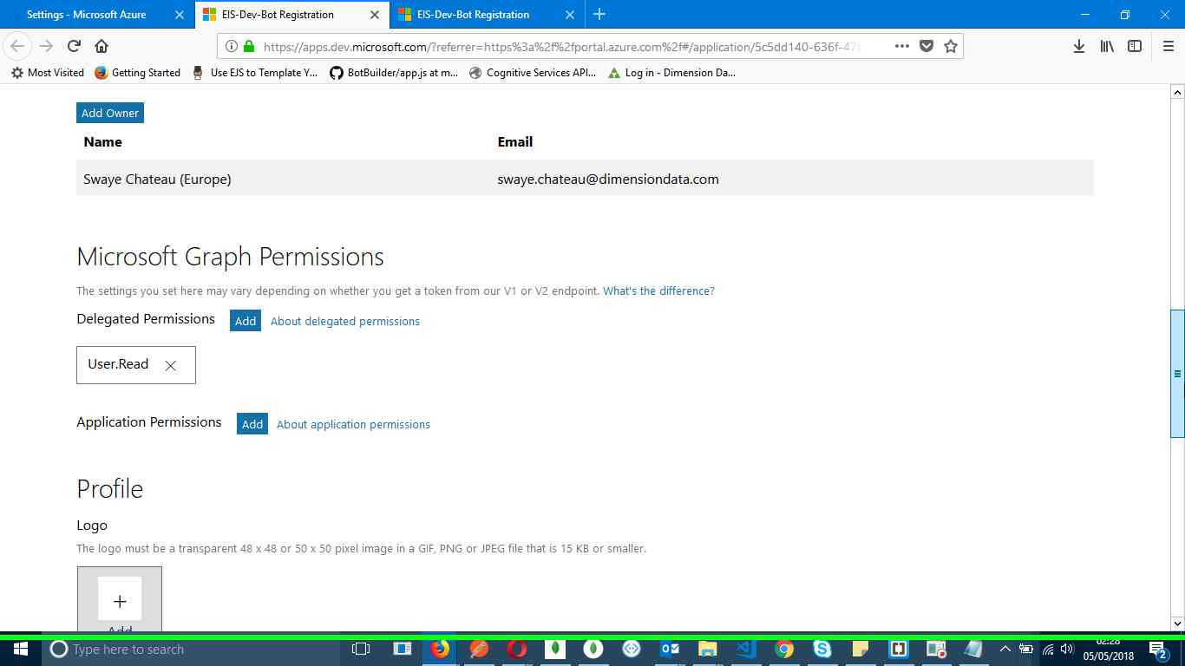Step 80 screenshot.

Previous Next

**Step 81: (‎05/‎05/‎2018 02:28:57)** User mouse drag start on "EIS-Dev-Bot Registration (document)" in "EIS-Dev-Bot Registration - Mozilla Firefox"

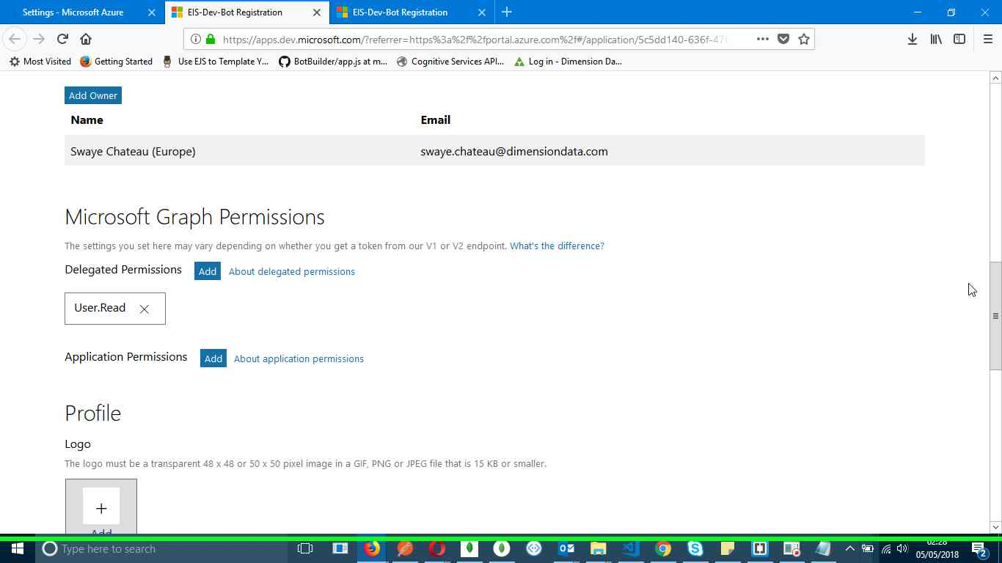Step 81 screenshot.

Previous Next

**Step 82: (‎05/‎05/‎2018 02:28:57)** User mouse drag end on "EIS-Dev-Bot Registration (document)" in "EIS-Dev-Bot Registration - Mozilla Firefox"

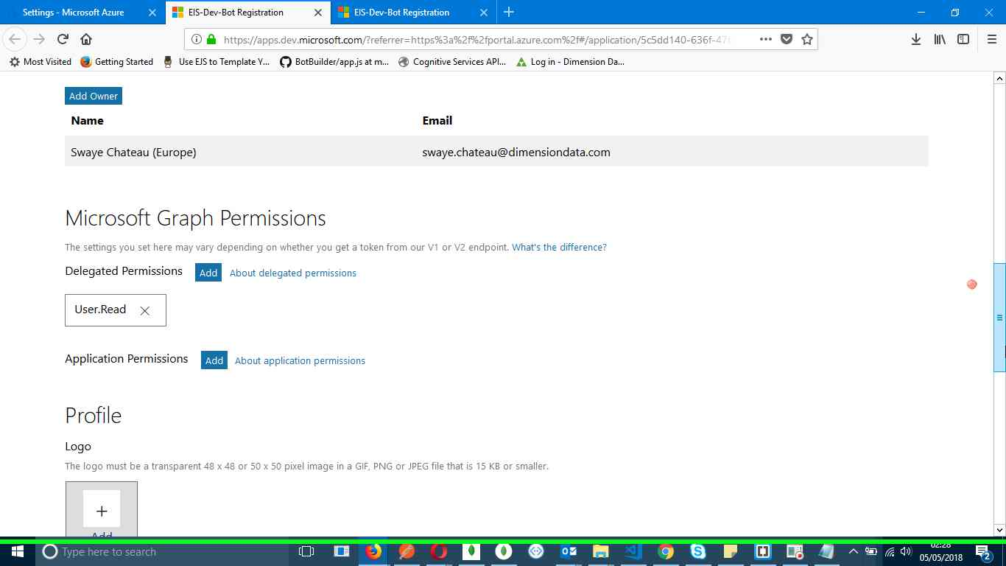Step 82 screenshot.

Previous Next

**Step 83: (‎05/‎05/‎2018 02:28:58)** User mouse drag start on "EIS-Dev-Bot Registration (document)" in "EIS-Dev-Bot Registration - Mozilla Firefox"

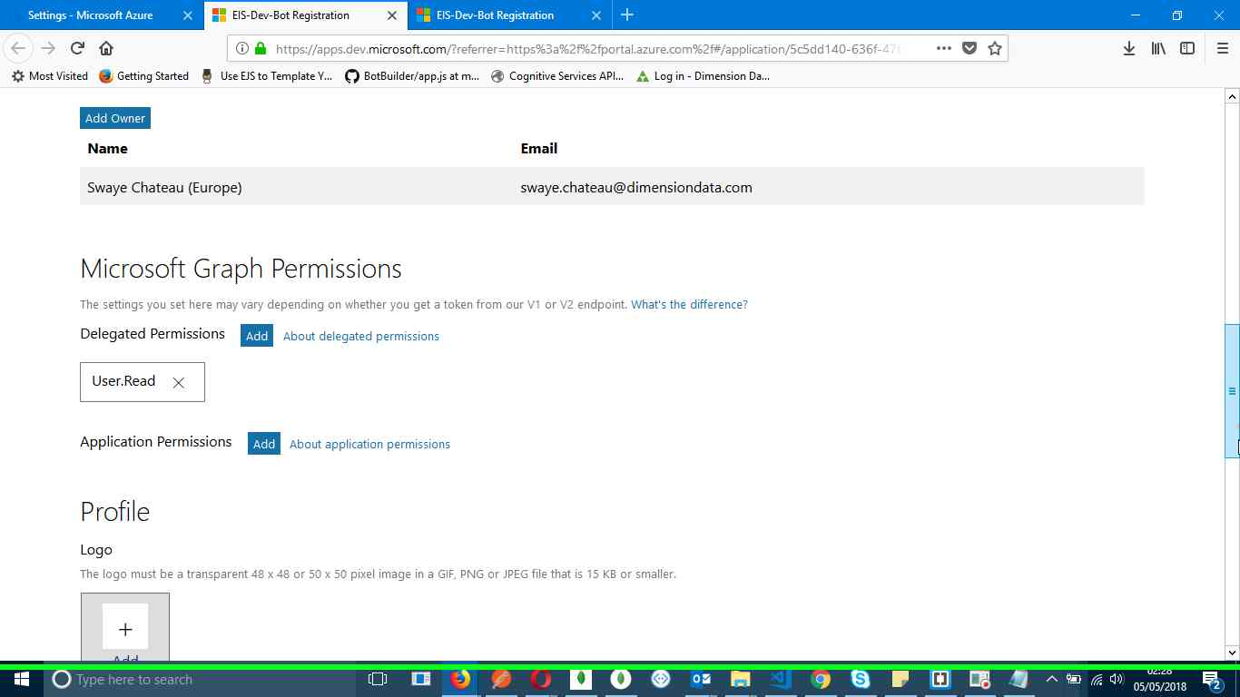Step 83 screenshot.

Previous Next

**Step 84: (‎05/‎05/‎2018 02:29:04)** User mouse drag end on "EIS-Dev-Bot Registration (document)" in "EIS-Dev-Bot Registration - Mozilla Firefox"

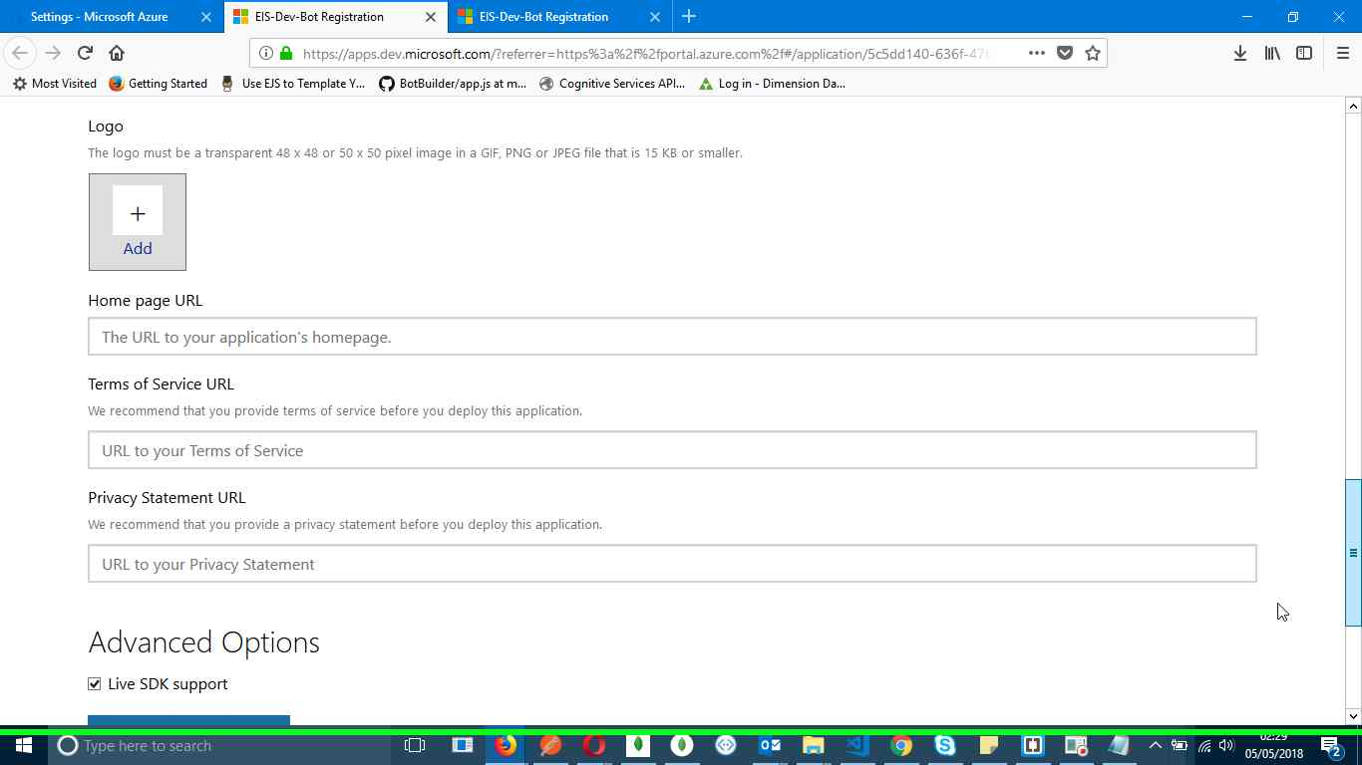Step 84 screenshot.

Previous Next

**Step 85: (‎05/‎05/‎2018 02:29:05)** User left click on "EIS-Dev-Bot Registration (document)" in "EIS-Dev-Bot Registration - Mozilla Firefox"

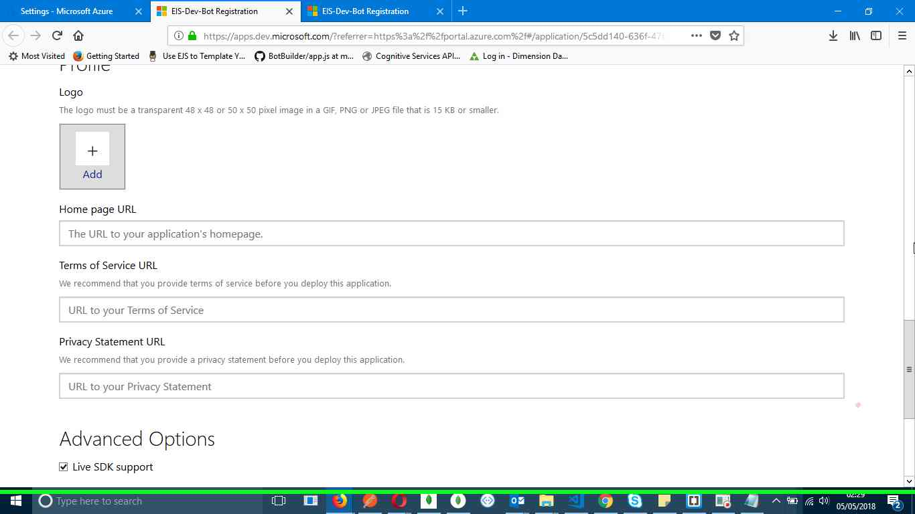Step 85 screenshot.

Previous Next

**Step 86: (‎05/‎05/‎2018 02:29:06)** User mouse drag start on "EIS-Dev-Bot Registration (document)" in "EIS-Dev-Bot Registration - Mozilla Firefox"

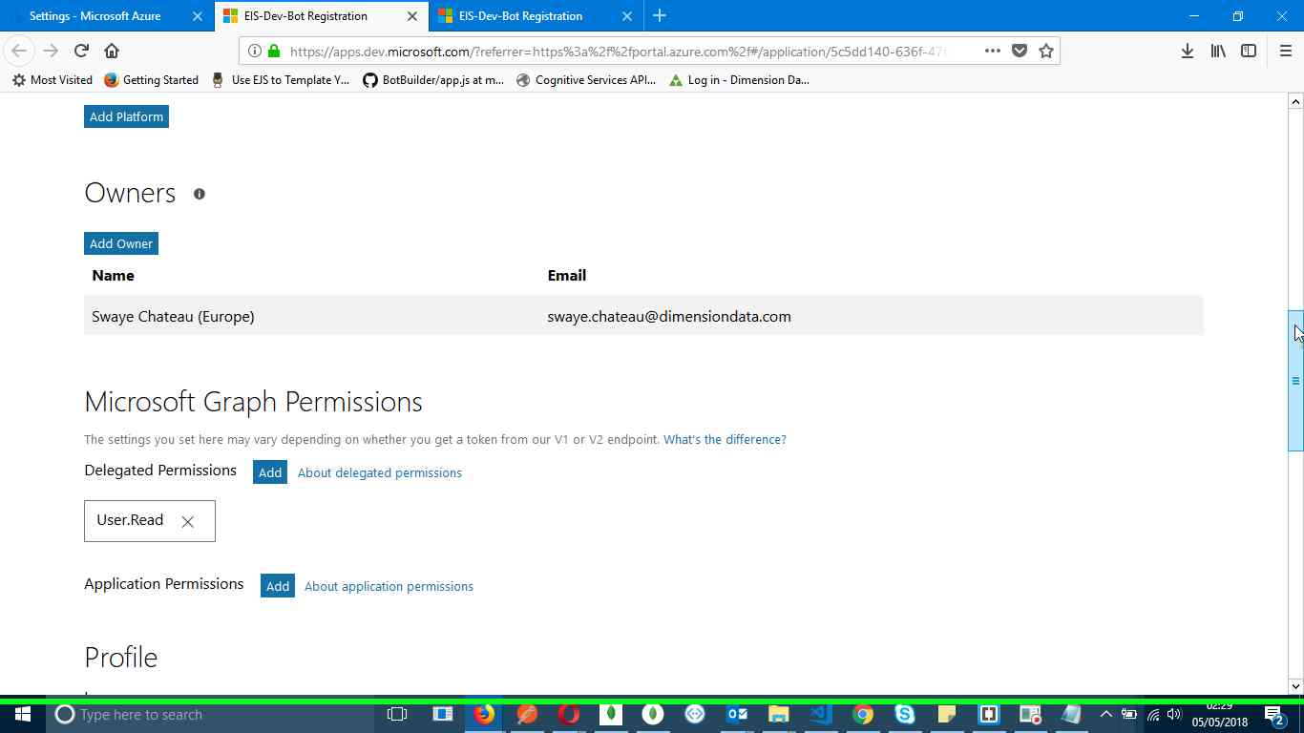Step 86 screenshot.

Previous Next

**Step 87: (‎05/‎05/‎2018 02:29:08)** User mouse drag end on "EIS-Dev-Bot Registration (document)" in "EIS-Dev-Bot Registration - Mozilla Firefox"

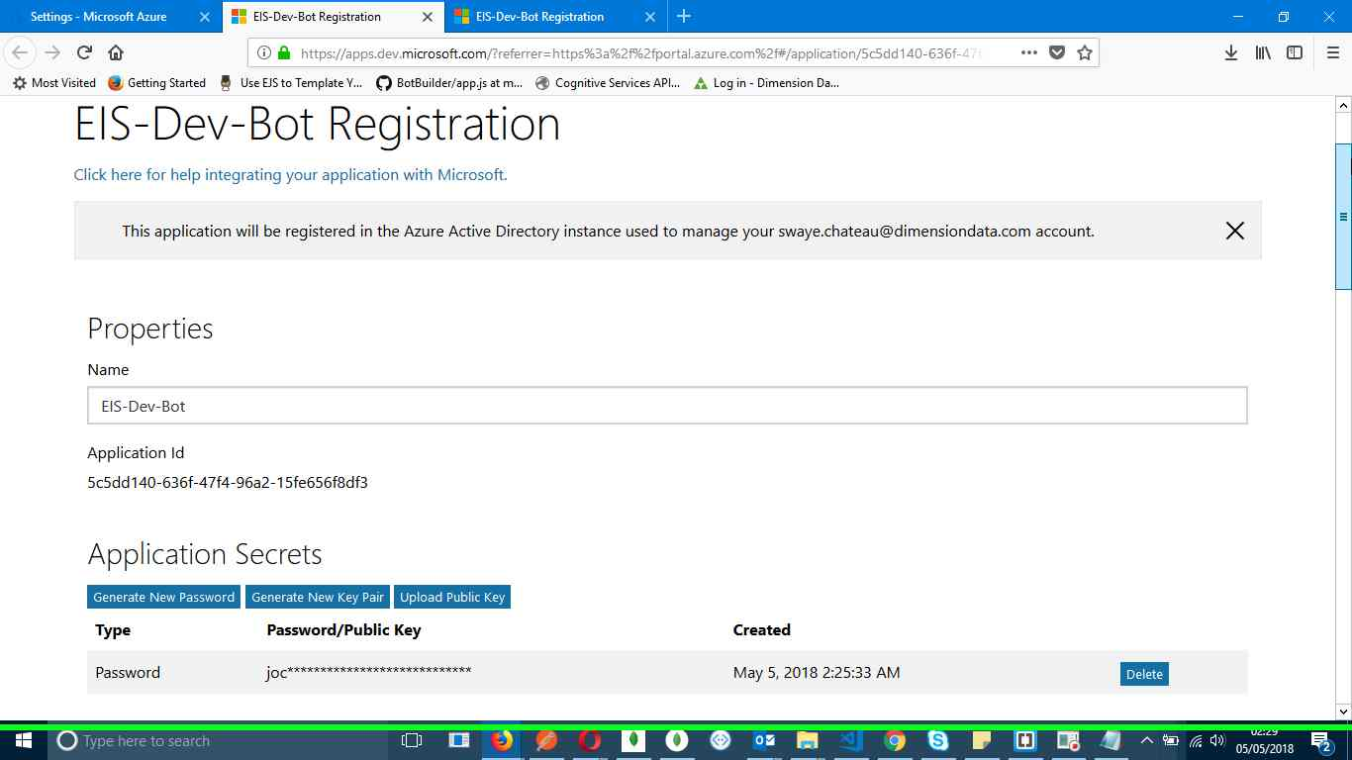Step 87 screenshot.

Previous Next

**Step 88: (‎05/‎05/‎2018 02:29:12)** User left click on "EIS-Dev-Bot Registration (tab item)" in "EIS-Dev-Bot Registration - Mozilla Firefox"

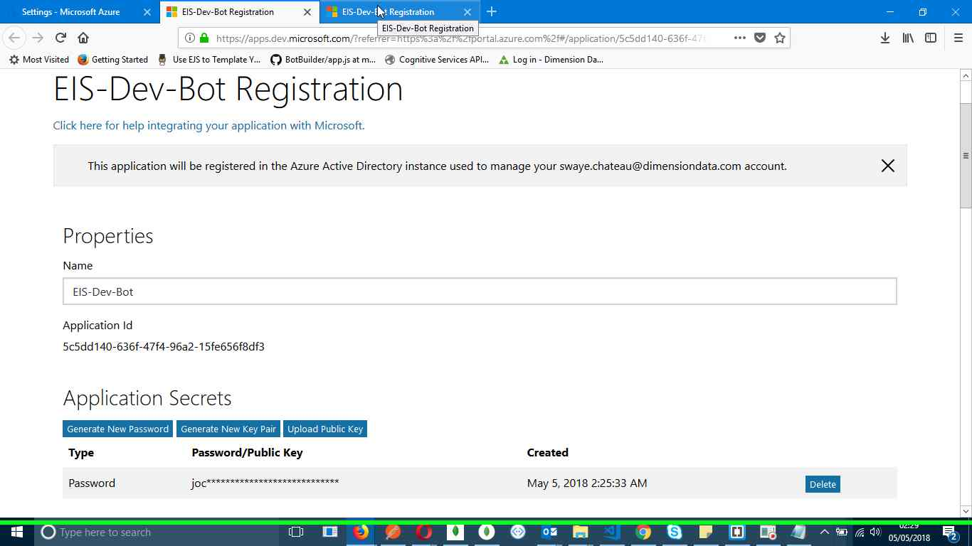Step 88 screenshot.

Previous Next

**Step 89: (‎05/‎05/‎2018 02:29:20)** User left click on "EIS-Dev-Bot Registration (tab item)" in "EIS-Dev-Bot Registration - Mozilla Firefox"

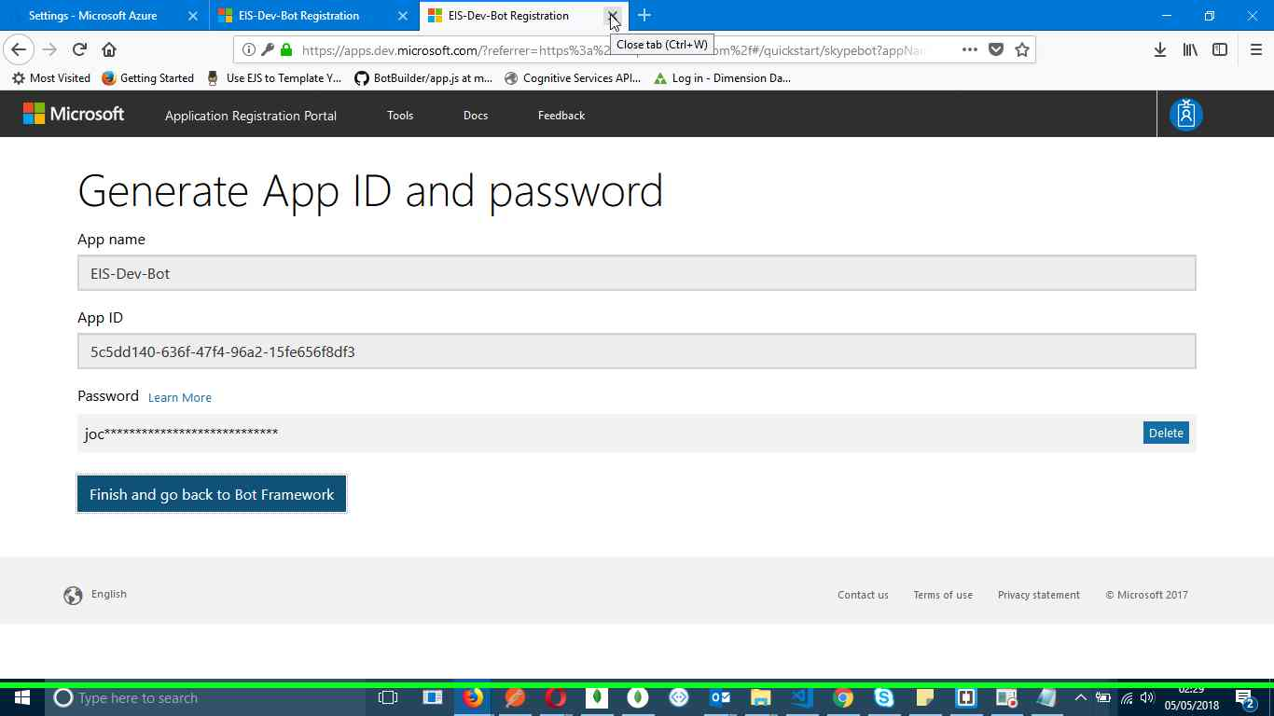Step 89 screenshot.

Previous Next

**Step 90: (‎05/‎05/‎2018 02:29:27)** User mouse drag start in "EIS-Dev-Bot Registration - Mozilla Firefox"

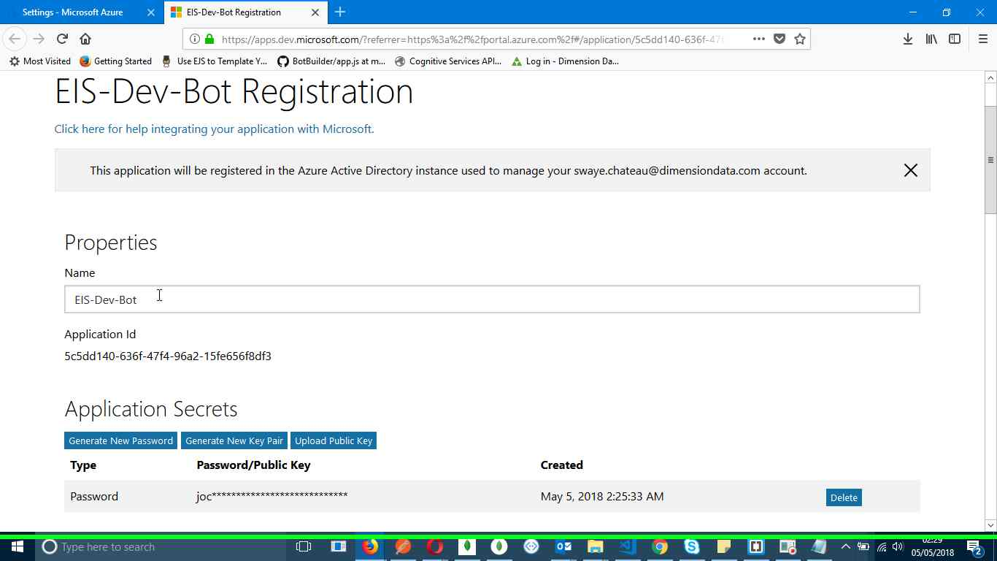Step 90 screenshot.

Previous Next

**Step 91: (‎05/‎05/‎2018 02:29:28)** User mouse drag end on "EIS-Dev-Bot Registration (document)" in "EIS-Dev-Bot Registration - Mozilla Firefox"

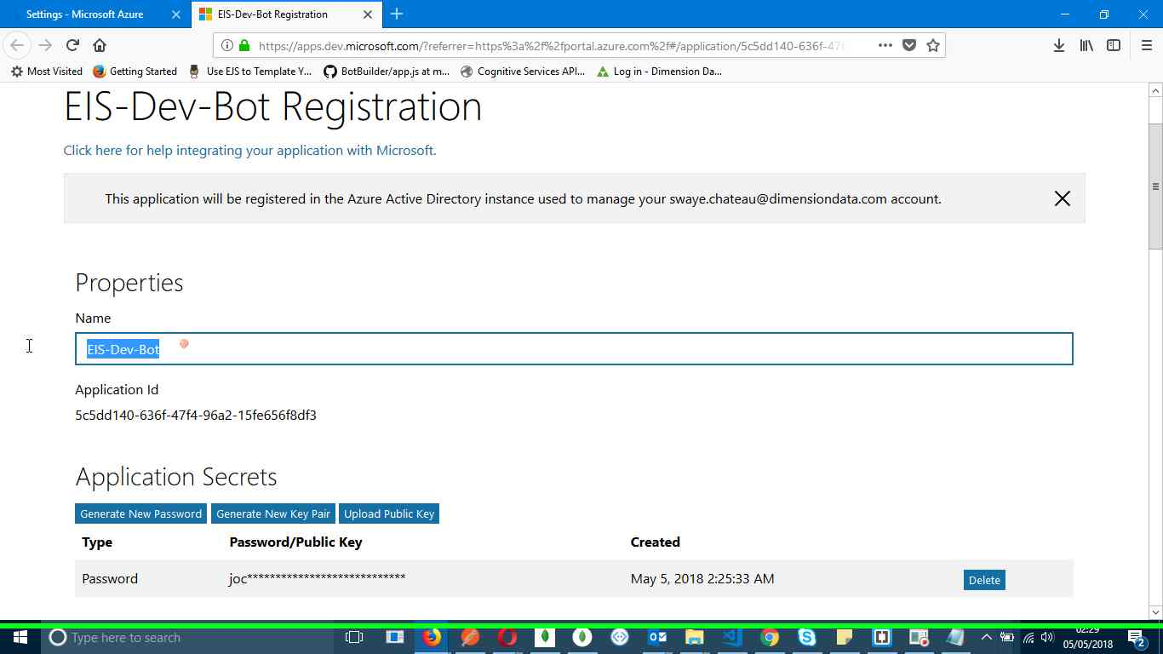Step 91 screenshot.

Previous Next

**Step 92: (‎05/‎05/‎2018 02:29:29)** User keyboard input on "EIS-Dev-Bot Registration - Mozilla Firefox (window)" in "EIS-Dev-Bot Registration - Mozilla Firefox" [... CTRL-C]

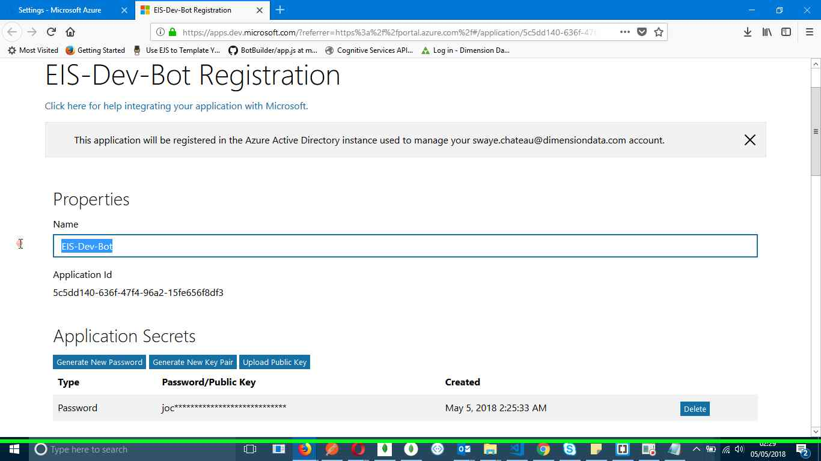Step 92 screenshot.

Previous Next

**Step 93: (‎05/‎05/‎2018 02:29:31)** User left click on "Notepad - 1 running window (button)"

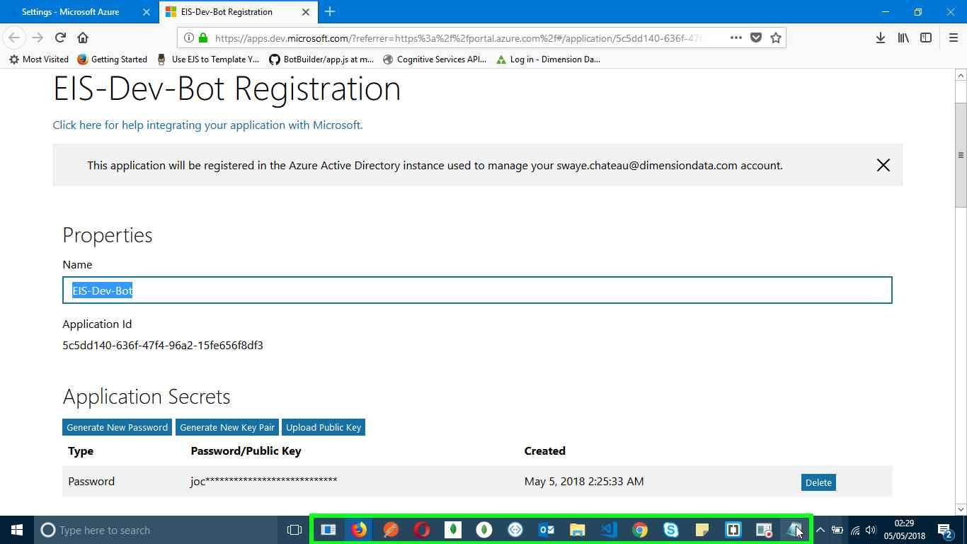Step 93 screenshot.

Previous Next

**Step 94: (‎05/‎05/‎2018 02:29:34)** User left click on "Untitled - Notepad (window)" in "Untitled - Notepad"

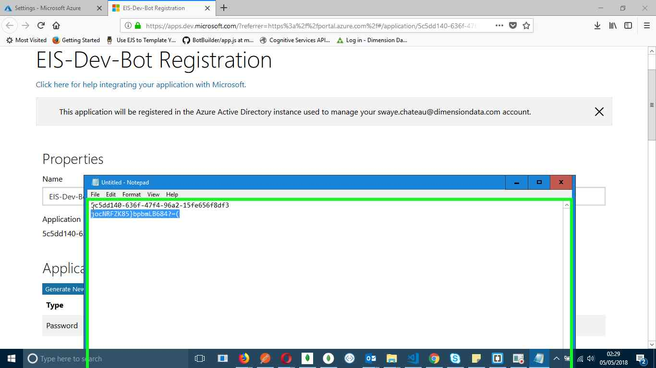Step 94 screenshot.

Previous Next

**Step 95: (‎05/‎05/‎2018 02:29:35)** User keyboard input on "Untitled - Notepad (window)" in "Untitled - Notepad" [ENTER UP ... CTRL-V]

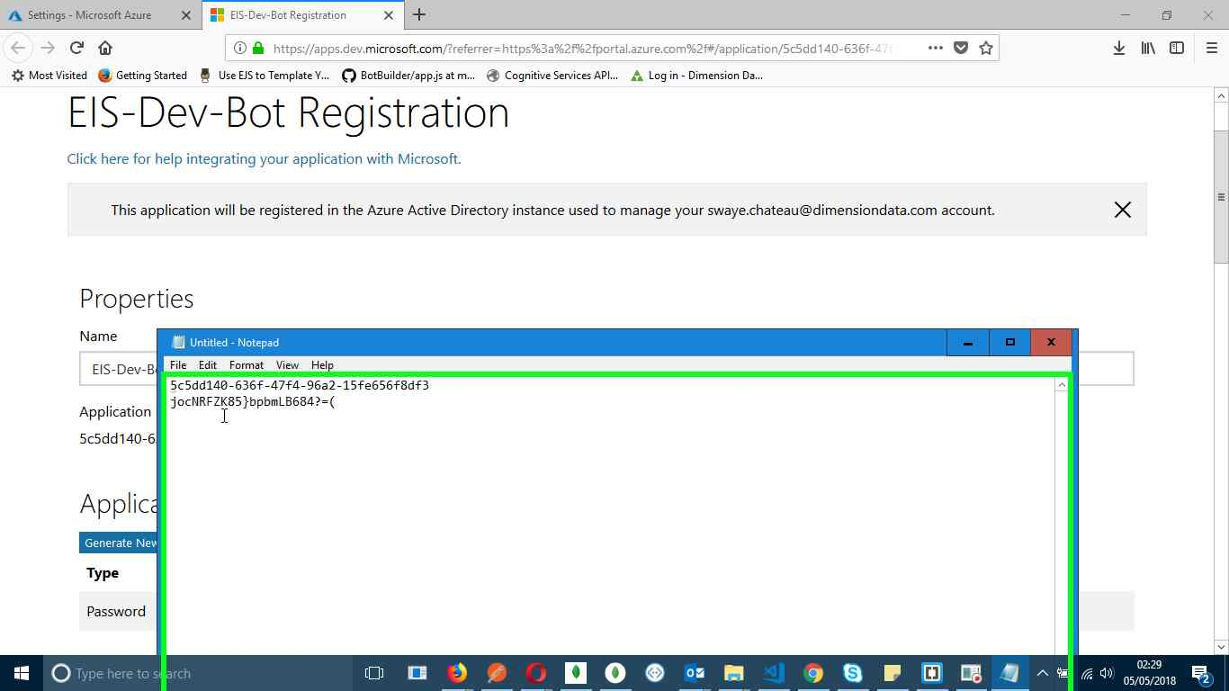Step 95 screenshot.

Previous Next

**Step 96: (‎05/‎05/‎2018 02:29:37)** User left click on "EIS-Dev-Bot Registration (document)" in "EIS-Dev-Bot Registration - Mozilla Firefox"

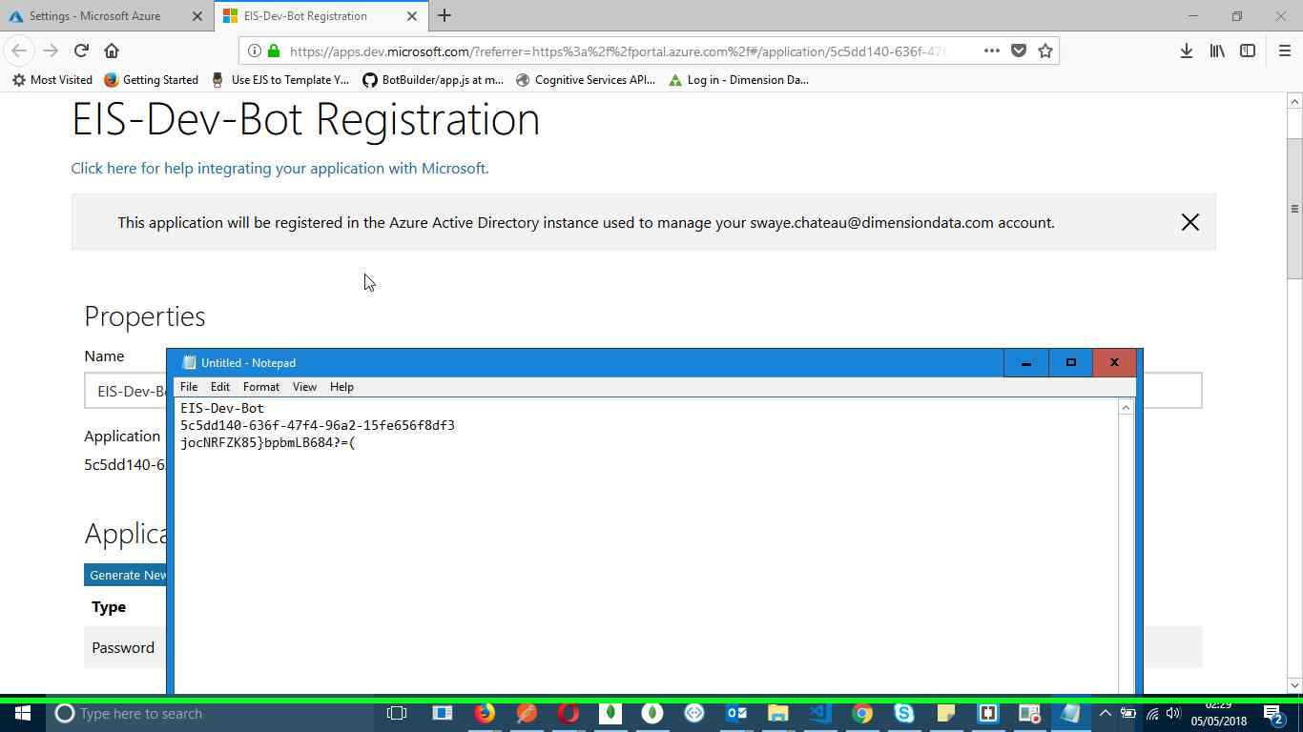Step 96 screenshot.

Previous Next

**Step 97: (‎05/‎05/‎2018 02:29:41)** User mouse drag start on "EIS-Dev-Bot Registration (document)" in "EIS-Dev-Bot Registration - Mozilla Firefox"

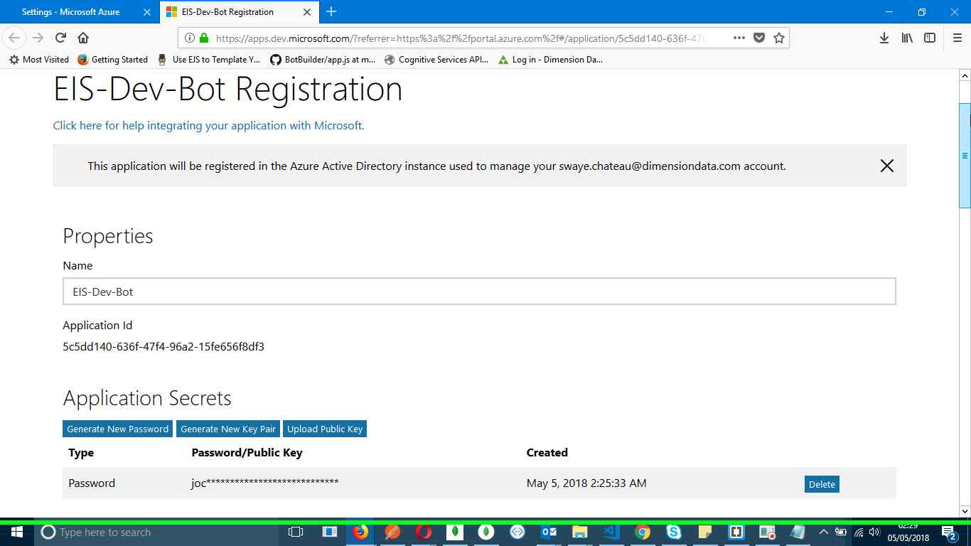Step 97 screenshot.

Previous Next

**Step 98: (‎05/‎05/‎2018 02:29:41)** User mouse drag end on "EIS-Dev-Bot Registration (document)" in "EIS-Dev-Bot Registration - Mozilla Firefox"

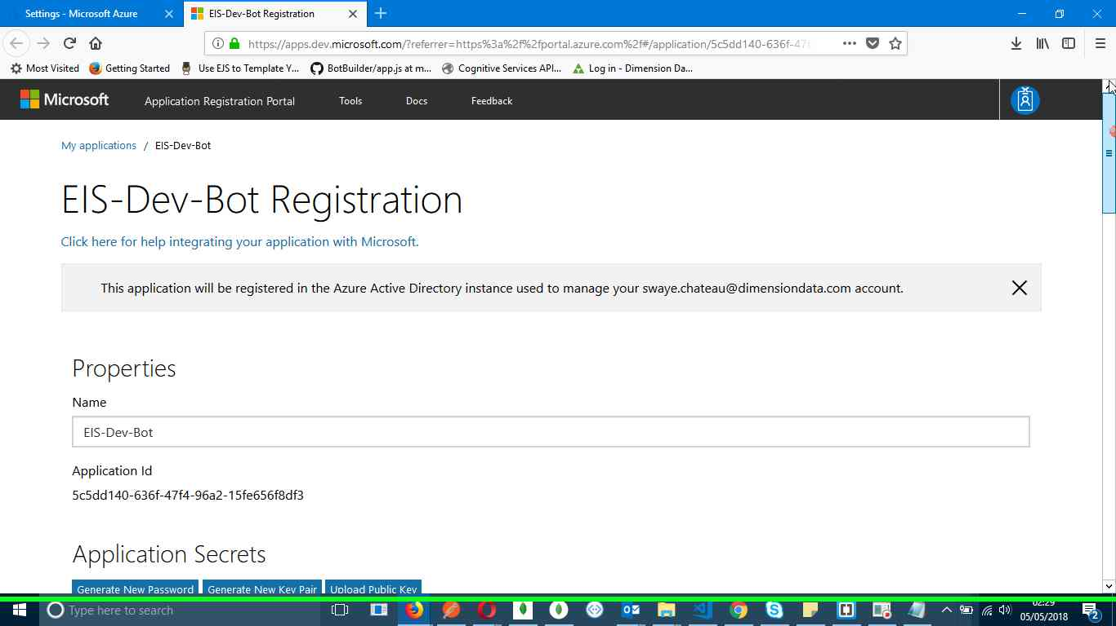Step 98 screenshot.

Previous Next

**Step 99: (‎05/‎05/‎2018 02:29:43)** User left click on "EIS-Dev-Bot Registration (tab item)" in "EIS-Dev-Bot Registration - Mozilla Firefox"

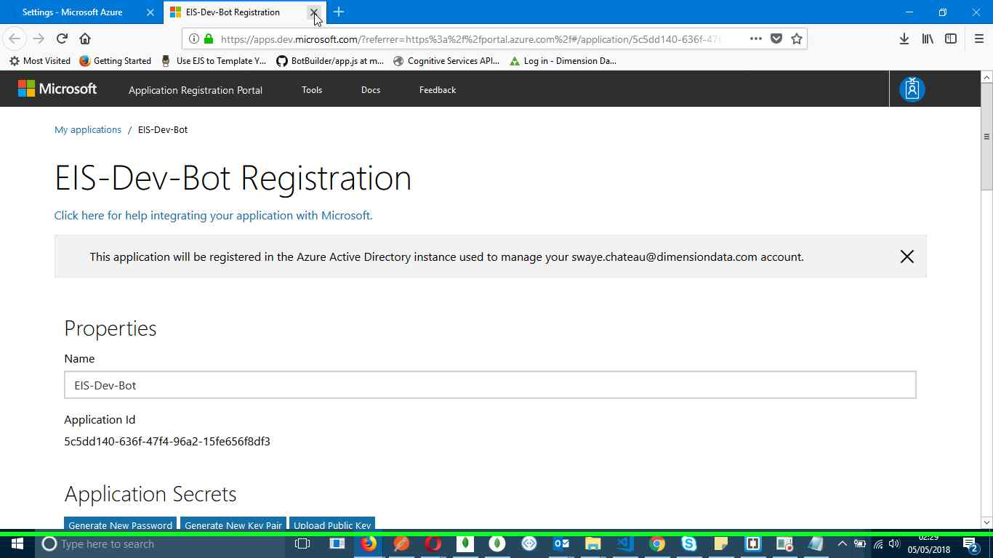Step 99 screenshot.

Previous Next

**Step 100: (‎05/‎05/‎2018 02:29:44)** User left click on "Browser tabs (tool bar)" in "Settings - Microsoft Azure - Mozilla Firefox"

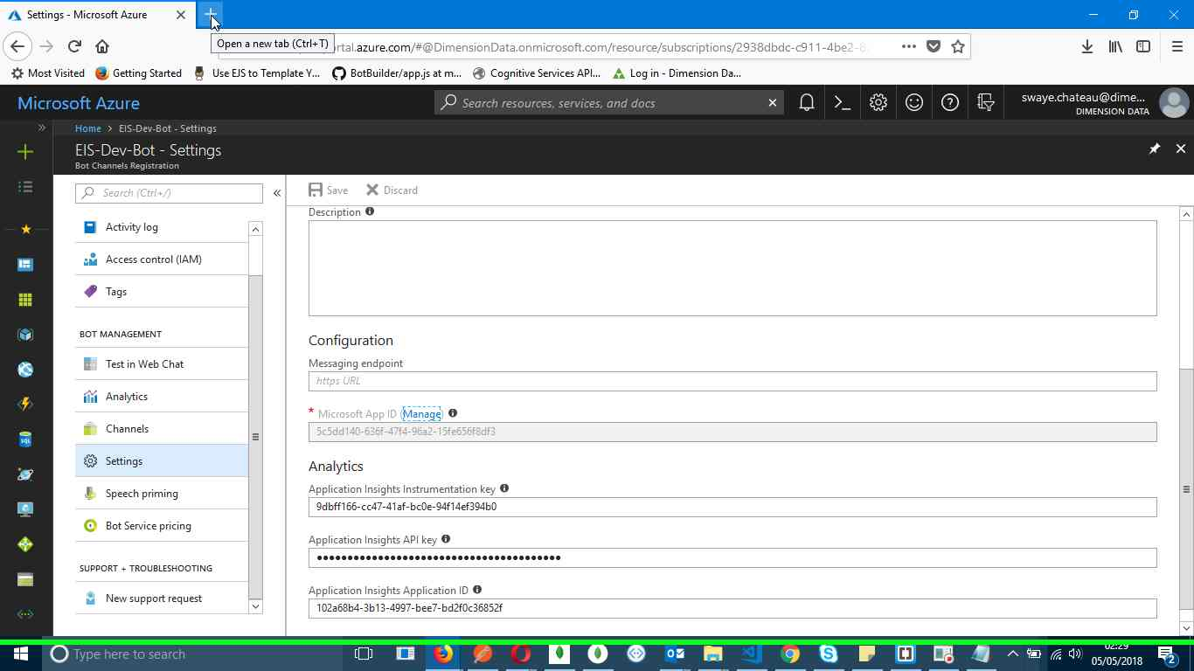Step 100 screenshot.

Previous Next

**Step 101: (‎05/‎05/‎2018 02:29:46)** User left click on "Search or enter address (edit)" in "Mozilla Firefox"

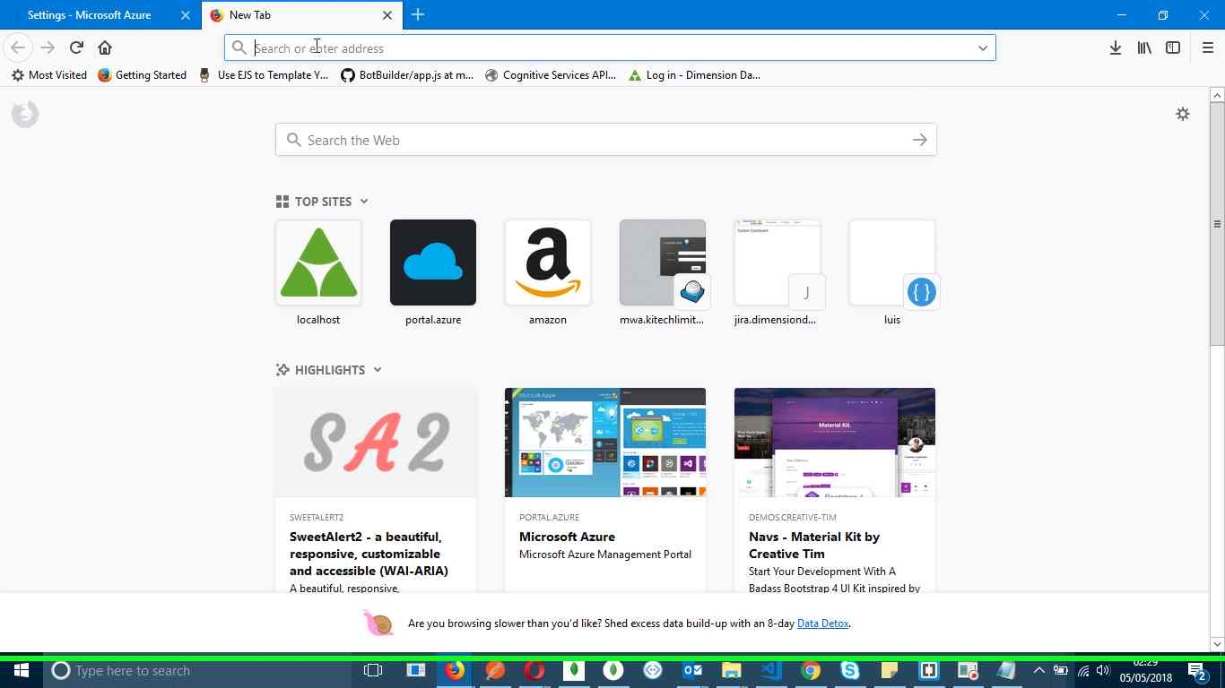Step 101 screenshot.

Previous Next

**Step 102: (‎05/‎05/‎2018 02:29:50)** User left click in "Mozilla Firefox"

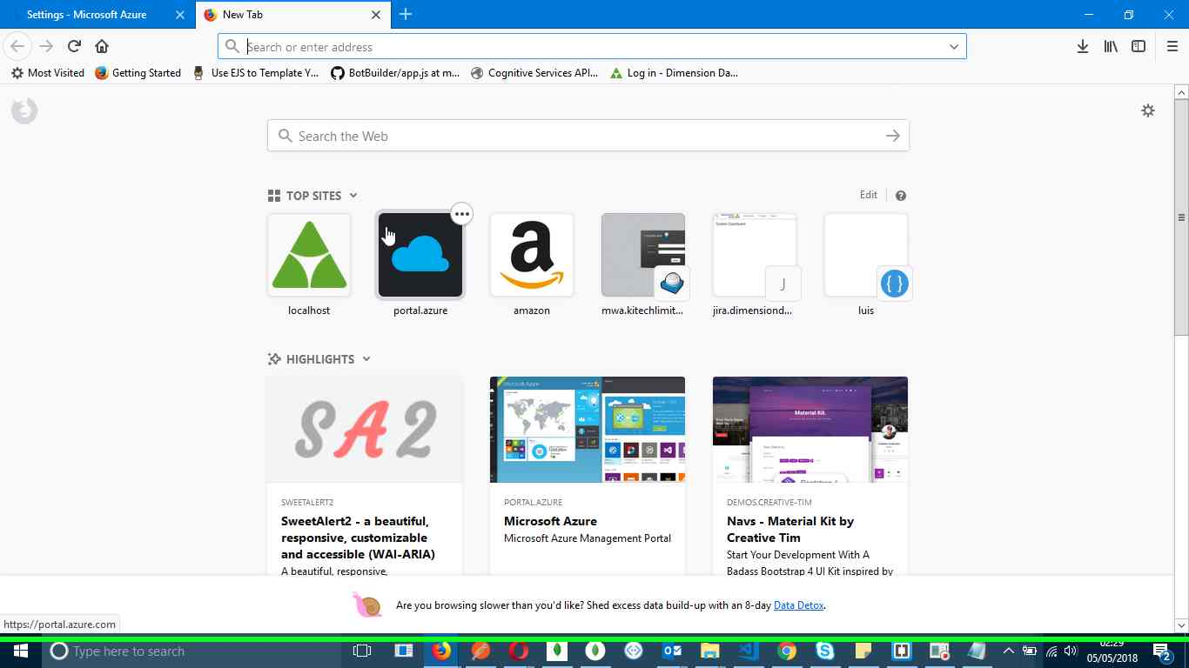Step 102 screenshot.

Previous Next

**Step 103: (‎05/‎05/‎2018 02:29:53)** User left click on "Dashboard - Microsoft Azure (tab item)" in "Dashboard - Microsoft Azure - Mozilla Firefox"

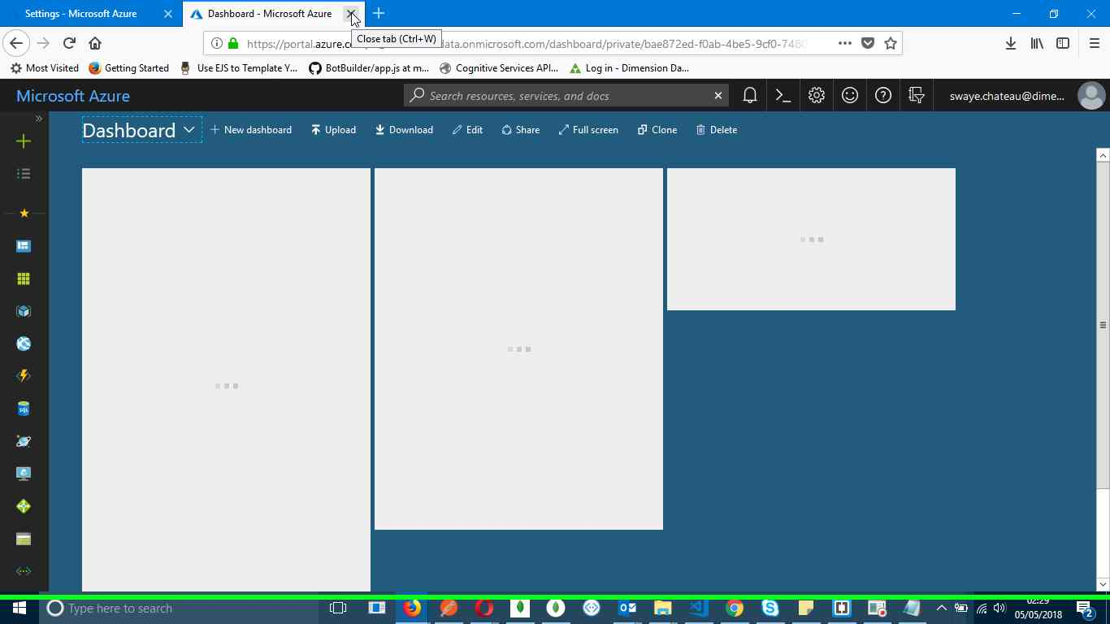Step 103 screenshot.

Previous Next

**Step 104: (‎05/‎05/‎2018 02:29:55)** User left click on "Steps Recorder - 1 running window (button)"

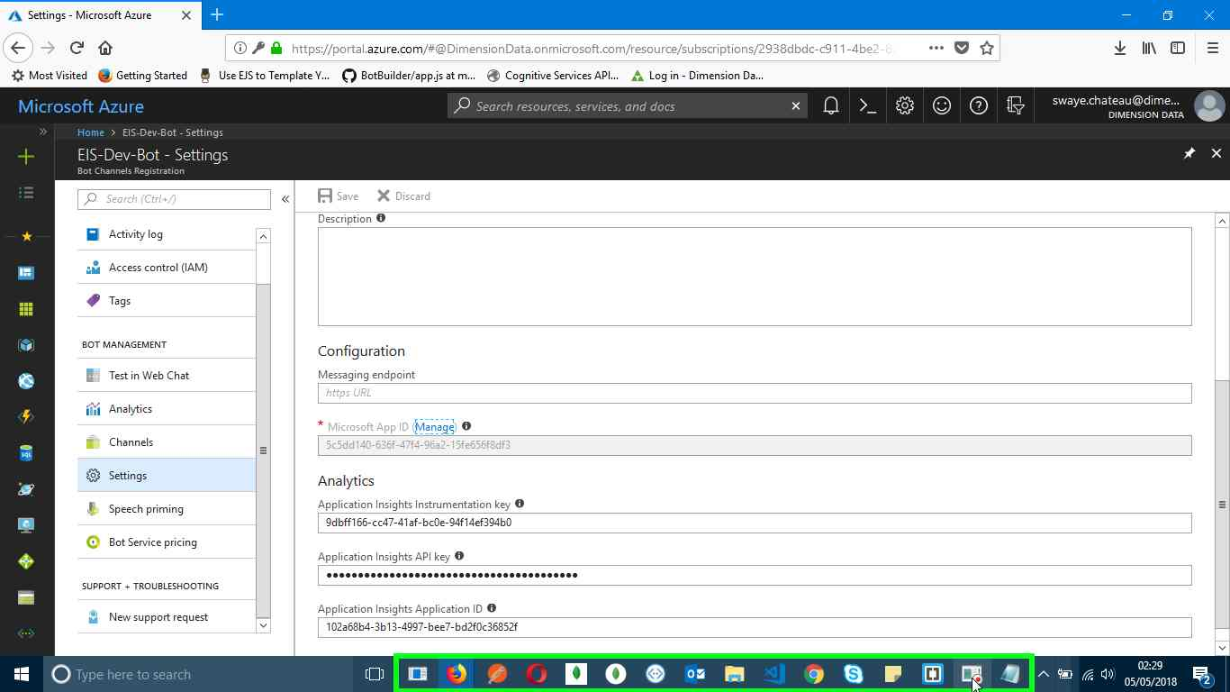Step 104 screenshot.

Return to top of page...

Additional Details

The following section contains the additional details that were recorded.

These details help accurately identify the programs and UI you used in this recording.

This section may contain text that is internal to programs that only very advanced users or programmers may understand.

Please review these details to ensure that they do not contain any information that you would not like others to see.

*Recording Session: ‎05/‎05/‎2018 02:23:19 - 02:29:57  
  
Recorded Steps: 104, Missed Steps: 0, Other Errors: 0  
  
Operating System: 14393.1770.amd64fre.rs1_release.170917-1700 10.0.0.0.2.4  
  
Step 1: User left click on "Search or enter address (edit)" in "New Tab - Mozilla Firefox"  
Program: Firefox, 59.0.3, Mozilla Corporation, FIREFOX.EXE, FIREFOX.EXE  
UI Elements: Search or enter address, Search or enter address, Navigation Toolbar, New Tab - Mozilla Firefox, MozillaWindowClass  
  
Step 2: User keyboard input on "New Tab - Mozilla Firefox (window)" in "New Tab - Mozilla Firefox" [... ENTER]  
Program: Firefox, 59.0.3, Mozilla Corporation, FIREFOX.EXE, FIREFOX.EXE  
UI Elements: New Tab - Mozilla Firefox, MozillaWindowClass  
  
Step 3: User left click on "Search or enter address (edit)" in "azreportal - Google Search - Mozilla Firefox"  
Program: Firefox, 59.0.3, Mozilla Corporation, FIREFOX.EXE, FIREFOX.EXE  
UI Elements: Search or enter address, Search or enter address, Navigation Toolbar, azreportal - Google Search - Mozilla Firefox, MozillaWindowClass  
  
Step 4: User keyboard input on "azreportal - Google Search - Mozilla Firefox (window)" in "azreportal - Google Search - Mozilla Firefox" [... BACKSPACE BACKSPACE BACKSPACE BACKSPACE BACKSPACE BACKSPACE ...]  
Program: Firefox, 59.0.3, Mozilla Corporation, FIREFOX.EXE, FIREFOX.EXE  
UI Elements: azreportal - Google Search - Mozilla Firefox, MozillaWindowClass  
  
Step 5: User left click on "ure (edit)"  
Program: Firefox, 59.0.3, Mozilla Corporation, FIREFOX.EXE, FIREFOX.EXE  
UI Elements: ure, Dashboard - Microsoft Azure, Dashboard - Microsoft Azure, Dashboard - Microsoft Azure https://portal.azure.com, MozillaDropShadowWindowClass, azreportal - Google Search - Mozilla Firefox, MozillaWindowClass  
  
Step 6: User left click on "Create a resource (button)" in "Dashboard - Microsoft Azure - Mozilla Firefox"  
Program: Firefox, 59.0.3, Mozilla Corporation, FIREFOX.EXE, FIREFOX.EXE  
UI Elements: Create a resource, Services, Dashboard - Microsoft Azure, Dashboard - Microsoft Azure - Mozilla Firefox, MozillaWindowClass  
  
Step 7: User left click in "New - Microsoft Azure - Mozilla Firefox"  
Program: Firefox, 59.0.3, Mozilla Corporation, FIREFOX.EXE, FIREFOX.EXE  
UI Elements:   
  
Step 8: User keyboard input on "New - Microsoft Azure - Mozilla Firefox (window)" in "New - Microsoft Azure - Mozilla Firefox" [... BACKSPACE]  
Program: Firefox, 59.0.3, Mozilla Corporation, FIREFOX.EXE, FIREFOX.EXE  
UI Elements: New - Microsoft Azure - Mozilla Firefox, MozillaWindowClass  
  
Step 9: User left click in "New - Microsoft Azure - Mozilla Firefox"  
Program: Firefox, 59.0.3, Mozilla Corporation, FIREFOX.EXE, FIREFOX.EXE  
UI Elements:   
  
Step 10: User left click in "Bot Channels Registration - Microsoft Azure - Mozilla Firefox"  
Program: Firefox, 59.0.3, Mozilla Corporation, FIREFOX.EXE, FIREFOX.EXE  
UI Elements:   
  
Step 11: User left click in "Bot Channels Registration - Microsoft Azure - Mozilla Firefox"  
Program: Firefox, 59.0.3, Mozilla Corporation, FIREFOX.EXE, FIREFOX.EXE  
UI Elements:   
  
Step 12: User keyboard input on "Bot Channels Registration - Microsoft Azure - Mozilla Firefox (window)" in "Bot Channels Registration - Microsoft Azure - Mozilla Firefox" [...]  
Program: Firefox, 59.0.3, Mozilla Corporation, FIREFOX.EXE, FIREFOX.EXE  
UI Elements: Bot Channels Registration - Microsoft Azure - Mozilla Firefox, MozillaWindowClass  
  
Step 13: User left click in "Bot Channels Registration - Microsoft Azure - Mozilla Firefox"  
Program: Firefox, 59.0.3, Mozilla Corporation, FIREFOX.EXE, FIREFOX.EXE  
UI Elements:   
  
Step 14: User mouse drag start in "Bot Channels Registration - Microsoft Azure - Mozilla Firefox"  
Program: Firefox, 59.0.3, Mozilla Corporation, FIREFOX.EXE, FIREFOX.EXE  
UI Elements:   
  
Step 15: User mouse drag end on "Bot Channels Registration ()" in "Bot Channels Registration - Microsoft Azure - Mozilla Firefox"  
Program: Firefox, 59.0.3, Mozilla Corporation, FIREFOX.EXE, FIREFOX.EXE  
UI Elements: Bot Channels Registration, Bot Channels Registration, Bot Channels Registration - Microsoft Azure, Bot Channels Registration - Microsoft Azure - Mozilla Firefox, MozillaWindowClass  
  
Step 16: User left click in "Bot Channels Registration - Microsoft Azure - Mozilla Firefox"  
Program: Firefox, 59.0.3, Mozilla Corporation, FIREFOX.EXE, FIREFOX.EXE  
UI Elements:   
  
Step 17: User left click in "Bot Channels Registration - Microsoft Azure - Mozilla Firefox"  
Program: Firefox, 59.0.3, Mozilla Corporation, FIREFOX.EXE, FIREFOX.EXE  
UI Elements:   
  
Step 18: User left click on " (10K Premium Messages) (edit)" in "Bot Channels Registration - Microsoft Azure - Mozilla Firefox"  
Program: Firefox, 59.0.3, Mozilla Corporation, FIREFOX.EXE, FIREFOX.EXE  
UI Elements: (10K Premium Messages), <span class='ext-hubs-sp-yellowGreen ext-hubs-sp-drop-text'>F0</span> (10K Premium Messages), All Available Pricing  
  
Step 19: User mouse drag start on "Bot Channels Registration ()" in "Bot Channels Registration - Microsoft Azure - Mozilla Firefox"  
Program: Firefox, 59.0.3, Mozilla Corporation, FIREFOX.EXE, FIREFOX.EXE  
UI Elements: Bot Channels Registration, Bot Channels Registration, Bot Channels Registration - Microsoft Azure, Bot Channels Registration - Microsoft Azure - Mozilla Firefox, MozillaWindowClass  
  
Step 20: User mouse drag end on "Bot Channels Registration ()" in "Bot Channels Registration - Microsoft Azure - Mozilla Firefox"  
Program: Firefox, 59.0.3, Mozilla Corporation, FIREFOX.EXE, FIREFOX.EXE  
UI Elements: Bot Channels Registration, Bot Channels Registration, Bot Channels Registration - Microsoft Azure, Bot Channels Registration - Microsoft Azure - Mozilla Firefox, MozillaWindowClass  
  
Step 21: User left click in "Bot Channels Registration - Microsoft Azure - Mozilla Firefox"  
Program: Firefox, 59.0.3, Mozilla Corporation, FIREFOX.EXE, FIREFOX.EXE  
UI Elements:   
  
Step 22: User left click in "Bot Channels Registration - Microsoft Azure - Mozilla Firefox"  
Program: Firefox, 59.0.3, Mozilla Corporation, FIREFOX.EXE, FIREFOX.EXE  
UI Elements:   
  
Step 23: User left click in "Bot Channels Registration - Microsoft Azure - Mozilla Firefox"  
Program: Firefox, 59.0.3, Mozilla Corporation, FIREFOX.EXE, FIREFOX.EXE  
UI Elements:   
  
Step 24: User left click in "Create Microsoft App ID - Microsoft Azure - Mozilla Firefox"  
Program: Firefox, 59.0.3, Mozilla Corporation, FIREFOX.EXE, FIREFOX.EXE  
UI Elements:   
  
Step 25: User left click in "Create new Microsoft App ID - Microsoft Azure - Mozilla Firefox"  
Program: Firefox, 59.0.3, Mozilla Corporation, FIREFOX.EXE, FIREFOX.EXE  
UI Elements:   
  
Step 26: User left click in "Sign in to your Microsoft account - Mozilla Firefox"  
Program: Firefox, 59.0.3, Mozilla Corporation, FIREFOX.EXE, FIREFOX.EXE  
UI Elements:   
  
Step 27: User keyboard input on "Sign in to your Microsoft account - Mozilla Firefox (window)" in "Sign in to your Microsoft account - Mozilla Firefox" [... ENTER]  
Program: Firefox, 59.0.3, Mozilla Corporation, FIREFOX.EXE, FIREFOX.EXE  
UI Elements: Sign in to your Microsoft account - Mozilla Firefox, MozillaWindowClass  
  
Step 28: User left click in "Sign In - Mozilla Firefox"  
Program: Firefox, 59.0.3, Mozilla Corporation, FIREFOX.EXE, FIREFOX.EXE  
UI Elements:   
  
Step 29: User keyboard input on "Sign In - Mozilla Firefox (window)" in "Sign In - Mozilla Firefox" [... TAB ... BACKSPACE BACKSPACE BACKSPACE BACKSPACE BACKSPACE ... ENTER]  
Program: Firefox, 59.0.3, Mozilla Corporation, FIREFOX.EXE, FIREFOX.EXE  
UI Elements: Sign In - Mozilla Firefox, MozillaWindowClass  
  
Step 30: User left click on "Yes (button)" in "Sign in to your account - Mozilla Firefox"  
Program: Firefox, 59.0.3, Mozilla Corporation, FIREFOX.EXE, FIREFOX.EXE  
UI Elements: Yes  
  
Step 31: User left click on "Generate an app password to continue (button)" in "EIS-Dev-Bot Registration - Mozilla Firefox"  
Program: Firefox, 59.0.3, Mozilla Corporation, FIREFOX.EXE, FIREFOX.EXE  
UI Elements: Generate an app password to continue, EIS-Dev-Bot Registration, EIS-Dev-Bot Registration - Mozilla Firefox, MozillaWindowClass  
  
Step 32: User mouse drag start on "EIS-Dev-Bot Registration (document)" in "EIS-Dev-Bot Registration - Mozilla Firefox"  
Program: Firefox, 59.0.3, Mozilla Corporation, FIREFOX.EXE, FIREFOX.EXE  
UI Elements: EIS-Dev-Bot Registration, EIS-Dev-Bot Registration - Mozilla Firefox, MozillaWindowClass  
  
Step 33: User mouse drag end on "EIS-Dev-Bot Registration (document)" in "EIS-Dev-Bot Registration - Mozilla Firefox"  
Program: Firefox, 59.0.3, Mozilla Corporation, FIREFOX.EXE, FIREFOX.EXE  
UI Elements: EIS-Dev-Bot Registration, EIS-Dev-Bot Registration - Mozilla Firefox, MozillaWindowClass  
  
Step 34: User keyboard input on "EIS-Dev-Bot Registration - Mozilla Firefox (window)" in "EIS-Dev-Bot Registration - Mozilla Firefox" [... CTRL-C]  
Program: Firefox, 59.0.3, Mozilla Corporation, FIREFOX.EXE, FIREFOX.EXE  
UI Elements: EIS-Dev-Bot Registration - Mozilla Firefox, MozillaWindowClass  
  
Step 35: User left click on "Type here to search (button)"  
Program: Windows Explorer, 10.0.14393.0 (rs1_release.160715-1616), Microsoft Corporation, EXPLORER.EXE, EXPLORER.EXE  
UI Elements: Type here to search, Button, TrayDummySearchControl, Shell_TrayWnd  
  
Step 36: User keyboard input on "Cortana (window)" in "Cortana" [... ENTER]  
Program: Search and Cortana application, 10.0.14393.953 (rs1_release_inmarket.170303-1614), Microsoft Corporation, SEARCHUI.EXE -SERVERNAME:CORTANAUI.APPXA50DQQA5GQV4A428C9Y1JJW7M3BTVEPJ.MCA, SEARCHUI.EXE  
UI Elements: Cortana, Windows.UI.Core.CoreWindow  
  
Step 37: User left click on "Untitled - Notepad (window)" in "Untitled - Notepad"  
Program: Notepad, 10.0.14393.0 (rs1_release.160715-1616), Microsoft Corporation, NOTEPAD.EXE, NOTEPAD.EXE  
UI Elements: Edit, Untitled - Notepad, Notepad  
  
Step 38: User keyboard input on "Untitled - Notepad (window)" in "Untitled - Notepad" [... CTRL-V]  
Program: Notepad, 10.0.14393.0 (rs1_release.160715-1616), Microsoft Corporation, NOTEPAD.EXE, NOTEPAD.EXE  
UI Elements: Edit, Untitled - Notepad, Notepad  
  
Step 39: User left click on "Minimize (button)" in "Untitled - Notepad"  
Program: Notepad, 10.0.14393.0 (rs1_release.160715-1616), Microsoft Corporation, NOTEPAD.EXE, NOTEPAD.EXE  
UI Elements: Minimize, Untitled - Notepad, Notepad  
  
Step 40: User left click on "Ok (button)" in "EIS-Dev-Bot Registration - Mozilla Firefox"  
Program: Firefox, 59.0.3, Mozilla Corporation, FIREFOX.EXE, FIREFOX.EXE  
UI Elements: Ok, EIS-Dev-Bot Registration, EIS-Dev-Bot Registration - Mozilla Firefox, MozillaWindowClass  
  
Step 41: User mouse drag start on "App ID (edit)" in "EIS-Dev-Bot Registration - Mozilla Firefox"  
Program: Firefox, 59.0.3, Mozilla Corporation, FIREFOX.EXE, FIREFOX.EXE  
UI Elements: App ID, EIS-Dev-Bot Registration, EIS-Dev-Bot Registration - Mozilla Firefox, MozillaWindowClass  
  
Step 42: User mouse drag end on "EIS-Dev-Bot Registration (document)" in "EIS-Dev-Bot Registration - Mozilla Firefox"  
Program: Firefox, 59.0.3, Mozilla Corporation, FIREFOX.EXE, FIREFOX.EXE  
UI Elements: EIS-Dev-Bot Registration, EIS-Dev-Bot Registration - Mozilla Firefox, MozillaWindowClass  
  
Step 43: User keyboard input on "EIS-Dev-Bot Registration - Mozilla Firefox (window)" in "EIS-Dev-Bot Registration - Mozilla Firefox" [... CTRL-C]  
Program: Firefox, 59.0.3, Mozilla Corporation, FIREFOX.EXE, FIREFOX.EXE  
UI Elements: EIS-Dev-Bot Registration - Mozilla Firefox, MozillaWindowClass  
  
Step 44: User left click on "Notepad - 1 running window (button)"  
Program: Windows Explorer, 10.0.14393.0 (rs1_release.160715-1616), Microsoft Corporation, EXPLORER.EXE, EXPLORER.EXE  
UI Elements: Notepad - 1 running window, Running applications, MSTaskListWClass, Running applications, MSTaskSwWClass, ReBarWindow32, Shell_TrayWnd  
  
Step 45: User keyboard input on "Untitled - Notepad (window)" in "Untitled - Notepad" [LEFT LEFT LEFT LEFT LEFT LEFT LEFT LEFT LEFT LEFT LEFT LEFT LEFT LEFT LEFT LEFT LEFT LEFT LEFT LEFT LEFT LEFT LEFT LEFT LEFT ENTER UP ... CTRL-V]  
Program: Notepad, 10.0.14393.0 (rs1_release.160715-1616), Microsoft Corporation, NOTEPAD.EXE, NOTEPAD.EXE  
UI Elements: Edit, Untitled - Notepad, Notepad  
  
Step 46: User mouse drag start on "App name (edit)" in "EIS-Dev-Bot Registration - Mozilla Firefox"  
Program: Firefox, 59.0.3, Mozilla Corporation, FIREFOX.EXE, FIREFOX.EXE  
UI Elements: App name, EIS-Dev-Bot Registration, EIS-Dev-Bot Registration - Mozilla Firefox, MozillaWindowClass  
  
Step 47: User mouse drag end on "App name (edit)" in "EIS-Dev-Bot Registration - Mozilla Firefox"  
Program: Firefox, 59.0.3, Mozilla Corporation, FIREFOX.EXE, FIREFOX.EXE  
UI Elements: App name, EIS-Dev-Bot Registration, EIS-Dev-Bot Registration - Mozilla Firefox, MozillaWindowClass  
  
Step 48: User left click on "App name (edit)" in "EIS-Dev-Bot Registration - Mozilla Firefox"  
Program: Firefox, 59.0.3, Mozilla Corporation, FIREFOX.EXE, FIREFOX.EXE  
UI Elements: App name, EIS-Dev-Bot Registration, EIS-Dev-Bot Registration - Mozilla Firefox, MozillaWindowClass  
  
Step 49: User mouse drag start on "App name (edit)" in "EIS-Dev-Bot Registration - Mozilla Firefox"  
Program: Firefox, 59.0.3, Mozilla Corporation, FIREFOX.EXE, FIREFOX.EXE  
UI Elements: App name, EIS-Dev-Bot Registration, EIS-Dev-Bot Registration - Mozilla Firefox, MozillaWindowClass  
  
Step 50: User mouse drag end on "App name (edit)" in "EIS-Dev-Bot Registration - Mozilla Firefox"  
Program: Firefox, 59.0.3, Mozilla Corporation, FIREFOX.EXE, FIREFOX.EXE  
UI Elements: App name, EIS-Dev-Bot Registration, EIS-Dev-Bot Registration - Mozilla Firefox, MozillaWindowClass  
  
Step 51: User left double click on "App name (edit)" in "EIS-Dev-Bot Registration - Mozilla Firefox"  
Program: Firefox, 59.0.3, Mozilla Corporation, FIREFOX.EXE, FIREFOX.EXE  
UI Elements: App name, EIS-Dev-Bot Registration, EIS-Dev-Bot Registration - Mozilla Firefox, MozillaWindowClass  
  
Step 52: User left click on "Finish and go back to Bot Framework (button)" in "EIS-Dev-Bot Registration - Mozilla Firefox"  
Program: Firefox, 59.0.3, Mozilla Corporation, FIREFOX.EXE, FIREFOX.EXE  
UI Elements: Finish and go back to Bot Framework, EIS-Dev-Bot Registration, EIS-Dev-Bot Registration - Mozilla Firefox, MozillaWindowClass  
  
Step 53: User left click on "Create new Microsoft App ID - Microsoft Azure (tab item)" in "EIS-Dev-Bot Registration - Mozilla Firefox"  
Program: Firefox, 59.0.3, Mozilla Corporation, FIREFOX.EXE, FIREFOX.EXE  
UI Elements: Create new Microsoft App ID - Microsoft Azure, Browser tabs, EIS-Dev-Bot Registration - Mozilla Firefox, MozillaWindowClass  
  
Step 54: User left click in "Create new Microsoft App ID - Microsoft Azure - Mozilla Firefox"  
Program: Firefox, 59.0.3, Mozilla Corporation, FIREFOX.EXE, FIREFOX.EXE  
UI Elements:   
  
Step 55: User keyboard input on "Create new Microsoft App ID - Microsoft Azure - Mozilla Firefox (window)" in "Create new Microsoft App ID - Microsoft Azure - Mozilla Firefox" [... CTRL-V]  
Program: Firefox, 59.0.3, Mozilla Corporation, FIREFOX.EXE, FIREFOX.EXE  
UI Elements: Create new Microsoft App ID - Microsoft Azure - Mozilla Firefox, MozillaWindowClass  
  
Step 56: User left click on "Notepad - 1 running window (button)"  
Program: Windows Explorer, 10.0.14393.0 (rs1_release.160715-1616), Microsoft Corporation, EXPLORER.EXE, EXPLORER.EXE  
UI Elements: Notepad - 1 running window, Running applications, MSTaskListWClass, Running applications, MSTaskSwWClass, ReBarWindow32, Shell_TrayWnd  
  
Step 57: User mouse drag start on "Untitled - Notepad (window)" in "Untitled - Notepad"  
Program: Notepad, 10.0.14393.0 (rs1_release.160715-1616), Microsoft Corporation, NOTEPAD.EXE, NOTEPAD.EXE  
UI Elements: Edit, Untitled - Notepad, Notepad  
  
Step 58: User mouse drag end on "Untitled - Notepad (window)" in "Untitled - Notepad"  
Program: Notepad, 10.0.14393.0 (rs1_release.160715-1616), Microsoft Corporation, NOTEPAD.EXE, NOTEPAD.EXE  
UI Elements: Edit, Untitled - Notepad, Notepad  
  
Step 59: User keyboard input on "Untitled - Notepad (window)" in "Untitled - Notepad" [... CTRL-C]  
Program: Notepad, 10.0.14393.0 (rs1_release.160715-1616), Microsoft Corporation, NOTEPAD.EXE, NOTEPAD.EXE  
UI Elements: Edit, Untitled - Notepad, Notepad  
  
Step 60: User left click in "Create new Microsoft App ID - Microsoft Azure - Mozilla Firefox"  
Program: Firefox, 59.0.3, Mozilla Corporation, FIREFOX.EXE, FIREFOX.EXE  
UI Elements:   
  
Step 61: User keyboard input on "Create new Microsoft App ID - Microsoft Azure - Mozilla Firefox (window)" in "Create new Microsoft App ID - Microsoft Azure - Mozilla Firefox" [... CTRL-V]  
Program: Firefox, 59.0.3, Mozilla Corporation, FIREFOX.EXE, FIREFOX.EXE  
UI Elements: Create new Microsoft App ID - Microsoft Azure - Mozilla Firefox, MozillaWindowClass  
  
Step 62: User left click in "Create new Microsoft App ID - Microsoft Azure - Mozilla Firefox"  
Program: Firefox, 59.0.3, Mozilla Corporation, FIREFOX.EXE, FIREFOX.EXE  
UI Elements:   
  
Step 63: User mouse drag start on "Bot Channels Registration ()" in "Bot Channels Registration - Microsoft Azure - Mozilla Firefox"  
Program: Firefox, 59.0.3, Mozilla Corporation, FIREFOX.EXE, FIREFOX.EXE  
UI Elements: Bot Channels Registration, Bot Channels Registration, Bot Channels Registration - Microsoft Azure, Bot Channels Registration - Microsoft Azure - Mozilla Firefox, MozillaWindowClass  
  
Step 64: User mouse drag end on "Bot Channels Registration ()" in "Bot Channels Registration - Microsoft Azure - Mozilla Firefox"  
Program: Firefox, 59.0.3, Mozilla Corporation, FIREFOX.EXE, FIREFOX.EXE  
UI Elements: Bot Channels Registration, Bot Channels Registration, Bot Channels Registration - Microsoft Azure, Bot Channels Registration - Microsoft Azure - Mozilla Firefox, MozillaWindowClass  
  
Step 65: User left click in "Bot Channels Registration - Microsoft Azure - Mozilla Firefox"  
Program: Firefox, 59.0.3, Mozilla Corporation, FIREFOX.EXE, FIREFOX.EXE  
UI Elements:   
  
Step 66: User left click on "Dashboard ()" in "Dashboard - Microsoft Azure - Mozilla Firefox"  
Program: Firefox, 59.0.3, Mozilla Corporation, FIREFOX.EXE, FIREFOX.EXE  
UI Elements: Dashboard, Dashboard - Microsoft Azure, Dashboard - Microsoft Azure - Mozilla Firefox, MozillaWindowClass  
  
Step 67: User left click on "Notifications (button)" in "Dashboard - Microsoft Azure - Mozilla Firefox"  
Program: Firefox, 59.0.3, Mozilla Corporation, FIREFOX.EXE, FIREFOX.EXE  
UI Elements: Notifications, Notifications 2 unread, Microsoft Azure, Dashboard - Microsoft Azure, Dashboard - Microsoft Azure - Mozilla Firefox, MozillaWindowClass  
  
Step 68: User left click in "Dashboard - Microsoft Azure - Mozilla Firefox"  
Program: Firefox, 59.0.3, Mozilla Corporation, FIREFOX.EXE, FIREFOX.EXE  
UI Elements:   
  
Step 69: User left click in "Dashboard - Microsoft Azure - Mozilla Firefox"  
Program: Firefox, 59.0.3, Mozilla Corporation, FIREFOX.EXE, FIREFOX.EXE  
UI Elements:   
  
Step 70: User left click on "Close (button)" in "EIS-Dev-Bot - Microsoft Azure - Mozilla Firefox"  
Program: Firefox, 59.0.3, Mozilla Corporation, FIREFOX.EXE, FIREFOX.EXE  
UI Elements: Close, Notifications, EIS-Dev-Bot - Microsoft Azure, EIS-Dev-Bot - Microsoft Azure - Mozilla Firefox, MozillaWindowClass  
  
Step 71: User mouse drag start in "EIS-Dev-Bot - Microsoft Azure - Mozilla Firefox"  
Program: Firefox, 59.0.3, Mozilla Corporation, FIREFOX.EXE, FIREFOX.EXE  
UI Elements:   
  
Step 72: User mouse drag end in "EIS-Dev-Bot - Microsoft Azure - Mozilla Firefox"  
Program: Firefox, 59.0.3, Mozilla Corporation, FIREFOX.EXE, FIREFOX.EXE  
UI Elements:   
  
Step 73: User left click in "EIS-Dev-Bot - Microsoft Azure - Mozilla Firefox"  
Program: Firefox, 59.0.3, Mozilla Corporation, FIREFOX.EXE, FIREFOX.EXE  
UI Elements:   
  
Step 74: User left click in "Settings - Microsoft Azure - Mozilla Firefox"  
Program: Firefox, 59.0.3, Mozilla Corporation, FIREFOX.EXE, FIREFOX.EXE  
UI Elements:   
  
Step 75: User mouse drag start in "Settings - Microsoft Azure - Mozilla Firefox"  
Program: Firefox, 59.0.3, Mozilla Corporation, FIREFOX.EXE, FIREFOX.EXE  
UI Elements:   
  
Step 76: User mouse drag end in "Settings - Microsoft Azure - Mozilla Firefox"  
Program: Firefox, 59.0.3, Mozilla Corporation, FIREFOX.EXE, FIREFOX.EXE  
UI Elements:   
  
Step 77: User left click in "Settings - Microsoft Azure - Mozilla Firefox"  
Program: Firefox, 59.0.3, Mozilla Corporation, FIREFOX.EXE, FIREFOX.EXE  
UI Elements:   
  
Step 78: User left click in "Settings - Microsoft Azure - Mozilla Firefox"  
Program: Firefox, 59.0.3, Mozilla Corporation, FIREFOX.EXE, FIREFOX.EXE  
UI Elements:   
  
Step 79: User mouse drag start on "EIS-Dev-Bot Registration (document)" in "EIS-Dev-Bot Registration - Mozilla Firefox"  
Program: Firefox, 59.0.3, Mozilla Corporation, FIREFOX.EXE, FIREFOX.EXE  
UI Elements: EIS-Dev-Bot Registration, EIS-Dev-Bot Registration - Mozilla Firefox, MozillaWindowClass  
  
Step 80: User mouse drag end on "EIS-Dev-Bot Registration (document)" in "EIS-Dev-Bot Registration - Mozilla Firefox"  
Program: Firefox, 59.0.3, Mozilla Corporation, FIREFOX.EXE, FIREFOX.EXE  
UI Elements: EIS-Dev-Bot Registration, EIS-Dev-Bot Registration - Mozilla Firefox, MozillaWindowClass  
  
Step 81: User mouse drag start on "EIS-Dev-Bot Registration (document)" in "EIS-Dev-Bot Registration - Mozilla Firefox"  
Program: Firefox, 59.0.3, Mozilla Corporation, FIREFOX.EXE, FIREFOX.EXE  
UI Elements: EIS-Dev-Bot Registration, EIS-Dev-Bot Registration - Mozilla Firefox, MozillaWindowClass  
  
Step 82: User mouse drag end on "EIS-Dev-Bot Registration (document)" in "EIS-Dev-Bot Registration - Mozilla Firefox"  
Program: Firefox, 59.0.3, Mozilla Corporation, FIREFOX.EXE, FIREFOX.EXE  
UI Elements: EIS-Dev-Bot Registration, EIS-Dev-Bot Registration - Mozilla Firefox, MozillaWindowClass  
  
Step 83: User mouse drag start on "EIS-Dev-Bot Registration (document)" in "EIS-Dev-Bot Registration - Mozilla Firefox"  
Program: Firefox, 59.0.3, Mozilla Corporation, FIREFOX.EXE, FIREFOX.EXE  
UI Elements: EIS-Dev-Bot Registration, EIS-Dev-Bot Registration - Mozilla Firefox, MozillaWindowClass  
  
Step 84: User mouse drag end on "EIS-Dev-Bot Registration (document)" in "EIS-Dev-Bot Registration - Mozilla Firefox"  
Program: Firefox, 59.0.3, Mozilla Corporation, FIREFOX.EXE, FIREFOX.EXE  
UI Elements: EIS-Dev-Bot Registration, EIS-Dev-Bot Registration - Mozilla Firefox, MozillaWindowClass  
  
Step 85: User left click on "EIS-Dev-Bot Registration (document)" in "EIS-Dev-Bot Registration - Mozilla Firefox"  
Program: Firefox, 59.0.3, Mozilla Corporation, FIREFOX.EXE, FIREFOX.EXE  
UI Elements: EIS-Dev-Bot Registration, EIS-Dev-Bot Registration - Mozilla Firefox, MozillaWindowClass  
  
Step 86: User mouse drag start on "EIS-Dev-Bot Registration (document)" in "EIS-Dev-Bot Registration - Mozilla Firefox"  
Program: Firefox, 59.0.3, Mozilla Corporation, FIREFOX.EXE, FIREFOX.EXE  
UI Elements: EIS-Dev-Bot Registration, EIS-Dev-Bot Registration - Mozilla Firefox, MozillaWindowClass  
  
Step 87: User mouse drag end on "EIS-Dev-Bot Registration (document)" in "EIS-Dev-Bot Registration - Mozilla Firefox"  
Program: Firefox, 59.0.3, Mozilla Corporation, FIREFOX.EXE, FIREFOX.EXE  
UI Elements: EIS-Dev-Bot Registration, EIS-Dev-Bot Registration - Mozilla Firefox, MozillaWindowClass  
  
Step 88: User left click on "EIS-Dev-Bot Registration (tab item)" in "EIS-Dev-Bot Registration - Mozilla Firefox"  
Program: Firefox, 59.0.3, Mozilla Corporation, FIREFOX.EXE, FIREFOX.EXE  
UI Elements: EIS-Dev-Bot Registration, Browser tabs, EIS-Dev-Bot Registration - Mozilla Firefox, MozillaWindowClass  
  
Step 89: User left click on "EIS-Dev-Bot Registration (tab item)" in "EIS-Dev-Bot Registration - Mozilla Firefox"  
Program: Firefox, 59.0.3, Mozilla Corporation, FIREFOX.EXE, FIREFOX.EXE  
UI Elements: EIS-Dev-Bot Registration, Browser tabs, EIS-Dev-Bot Registration - Mozilla Firefox, MozillaWindowClass  
  
Step 90: User mouse drag start in "EIS-Dev-Bot Registration - Mozilla Firefox"  
Program: Firefox, 59.0.3, Mozilla Corporation, FIREFOX.EXE, FIREFOX.EXE  
UI Elements:   
  
Step 91: User mouse drag end on "EIS-Dev-Bot Registration (document)" in "EIS-Dev-Bot Registration - Mozilla Firefox"  
Program: Firefox, 59.0.3, Mozilla Corporation, FIREFOX.EXE, FIREFOX.EXE  
UI Elements: EIS-Dev-Bot Registration, EIS-Dev-Bot Registration - Mozilla Firefox, MozillaWindowClass  
  
Step 92: User keyboard input on "EIS-Dev-Bot Registration - Mozilla Firefox (window)" in "EIS-Dev-Bot Registration - Mozilla Firefox" [... CTRL-C]  
Program: Firefox, 59.0.3, Mozilla Corporation, FIREFOX.EXE, FIREFOX.EXE  
UI Elements: EIS-Dev-Bot Registration - Mozilla Firefox, MozillaWindowClass  
  
Step 93: User left click on "Notepad - 1 running window (button)"  
Program: Windows Explorer, 10.0.14393.0 (rs1_release.160715-1616), Microsoft Corporation, EXPLORER.EXE, EXPLORER.EXE  
UI Elements: Notepad - 1 running window, Running applications, MSTaskListWClass, Running applications, MSTaskSwWClass, ReBarWindow32, Shell_TrayWnd  
  
Step 94: User left click on "Untitled - Notepad (window)" in "Untitled - Notepad"  
Program: Notepad, 10.0.14393.0 (rs1_release.160715-1616), Microsoft Corporation, NOTEPAD.EXE, NOTEPAD.EXE  
UI Elements: Edit, Untitled - Notepad, Notepad  
  
Step 95: User keyboard input on "Untitled - Notepad (window)" in "Untitled - Notepad" [ENTER UP ... CTRL-V]  
Program: Notepad, 10.0.14393.0 (rs1_release.160715-1616), Microsoft Corporation, NOTEPAD.EXE, NOTEPAD.EXE  
UI Elements: Edit, Untitled - Notepad, Notepad  
  
Step 96: User left click on "EIS-Dev-Bot Registration (document)" in "EIS-Dev-Bot Registration - Mozilla Firefox"  
Program: Firefox, 59.0.3, Mozilla Corporation, FIREFOX.EXE, FIREFOX.EXE  
UI Elements: EIS-Dev-Bot Registration, EIS-Dev-Bot Registration - Mozilla Firefox, MozillaWindowClass  
  
Step 97: User mouse drag start on "EIS-Dev-Bot Registration (document)" in "EIS-Dev-Bot Registration - Mozilla Firefox"  
Program: Firefox, 59.0.3, Mozilla Corporation, FIREFOX.EXE, FIREFOX.EXE  
UI Elements: EIS-Dev-Bot Registration, EIS-Dev-Bot Registration - Mozilla Firefox, MozillaWindowClass  
  
Step 98: User mouse drag end on "EIS-Dev-Bot Registration (document)" in "EIS-Dev-Bot Registration - Mozilla Firefox"  
Program: Firefox, 59.0.3, Mozilla Corporation, FIREFOX.EXE, FIREFOX.EXE  
UI Elements: EIS-Dev-Bot Registration, EIS-Dev-Bot Registration - Mozilla Firefox, MozillaWindowClass  
  
Step 99: User left click on "EIS-Dev-Bot Registration (tab item)" in "EIS-Dev-Bot Registration - Mozilla Firefox"  
Program: Firefox, 59.0.3, Mozilla Corporation, FIREFOX.EXE, FIREFOX.EXE  
UI Elements: EIS-Dev-Bot Registration, Browser tabs, EIS-Dev-Bot Registration - Mozilla Firefox, MozillaWindowClass  
  
Step 100: User left click on "Browser tabs (tool bar)" in "Settings - Microsoft Azure - Mozilla Firefox"  
Program: Firefox, 59.0.3, Mozilla Corporation, FIREFOX.EXE, FIREFOX.EXE  
UI Elements: Browser tabs, Settings - Microsoft Azure - Mozilla Firefox, MozillaWindowClass  
  
Step 101: User left click on "Search or enter address (edit)" in "Mozilla Firefox"  
Program: Firefox, 59.0.3, Mozilla Corporation, FIREFOX.EXE, FIREFOX.EXE  
UI Elements: Search or enter address, Search or enter address, Navigation Toolbar, Mozilla Firefox, MozillaWindowClass  
  
Step 102: User left click in "Mozilla Firefox"  
Program: Firefox, 59.0.3, Mozilla Corporation, FIREFOX.EXE, FIREFOX.EXE  
UI Elements:   
  
Step 103: User left click on "Dashboard - Microsoft Azure (tab item)" in "Dashboard - Microsoft Azure - Mozilla Firefox"  
Program: Firefox, 59.0.3, Mozilla Corporation, FIREFOX.EXE, FIREFOX.EXE  
UI Elements: Dashboard - Microsoft Azure, Browser tabs, Dashboard - Microsoft Azure - Mozilla Firefox, MozillaWindowClass  
  
Step 104: User left click on "Steps Recorder - 1 running window (button)"  
Program: Windows Explorer, 10.0.14393.0 (rs1_release.160715-1616), Microsoft Corporation, EXPLORER.EXE, EXPLORER.EXE  
UI Elements: Steps Recorder - 1 running window, Running applications, MSTaskListWClass, Running applications, MSTaskSwWClass, ReBarWindow32, Shell_TrayWnd*

Return to top of page...